

**NETAJI SUBHAS UNIVERSITY**

**OF TECHNOLOGY**

**INFORMATION SECURITY**

ABHISHEK KUMAR SAH

2019UIT3001

**IT-1**

**INDEX**

|  |  |
| --- | --- |
| **S. NO** | **PRACTICAL** |
| **1.** | **Study of the features of firewall in providing network security and to set Firewall**  **security in windows. Students should know the following:**  **a) Know how to setup and configure a firewall on Operating System.**  **b) Know about the Windows Firewall with Advanced Security.**  **c) Know the Connection Security Rules**  **d) Know How to Start & Use the Windows Firewall with Advanced Security** |
| **2.** | **Demonstrate how to provide secure data storage, secure data transmission and for creating digital signatures Using tool GnuPG. (Download GPG4Win Tool). Create your public and private keys using Kloepatra Certificate management software. Check encryption –decryption of an email sent to you.** |
| **3.** | **Implement MD5 Algorithm. Take all the constants from the Figure attached implement in Python** |
| **4.** | **Implement SHA-256 Algorithm. Consider all the Constants and Tables as given in the text book.** |
| **5.** | **Plot an elliptic curve over finite field. Check whether the points lies on the elliptic curve or not.** |
| **6.** | **Perform the Elliptic Curve operations like Addition and Multiplication of two points and find the Inverse of a point also.** |
| **7.** | **Implement RSA Digital Signature Scheme.** |
| **8.** | **Implement Elgamal Digital Signature Scheme**. |
| **9.** | **Implement Schnorr Digital Signature Scheme** |
| **10.** | **Using Jcrypt tool (or any other equivalent) to demonstrate asymmetric, symmetric crypto algorithm** |
| **11.** | **Implement the Identity-based Encryption (IBE). Use the email address of the recipient to generate the key for a destination.** |
| **12.** | **To study and work with KF SENSOR Intrusion Detection Tool. Setup a honeypot and monitor the honeypot on the network.** |
| **13.** | **Configure Wireshark with a key to let you look inside encrypted SSL messages. You can read on the web how to do this. Once decrypted, you will be able to observe the HTTP protocol running on top of SSL, as well as the details of other SSL messages such as Alerts** |
| **14.** | **To build a Trojan and know the harmness of the trojan malwares in a computer system. When the trojan code executes, it will open MS-Paint, Notepad, Command Prompt, Explorer, calculator, infinitely. Note: Use Vmware to perform this experiment** |
| **15.** | **To work with Snort tool to demonstrate Intrusion Detection System. Download SNORT from snort.org.** |
| **16.** | **Implement a code to simulate buffer overflow attack.** |
| **17.** | **Use the Nessus tool to scan the network for vulnerabilities** |

**STUDY OF THE FEATURES OF FIREWALL IN PROVIDING NETWORK SECURITY AND TO SET FIREWALL SECURITY IN WINDOWS. STUDENTS SHOULD KNOW THE FOLLOWING:**

a) Know how to setup and configure a firewall on Operating System.

b) Know about the Windows Firewall with Advanced Security.

c) Know the Connection Security Rules.

d) Know How to Start & Use the Windows Firewall with Advanced Security.

* **How to step and configure a firewall.**

1) Click on start button in windows 10 and then open up settings.

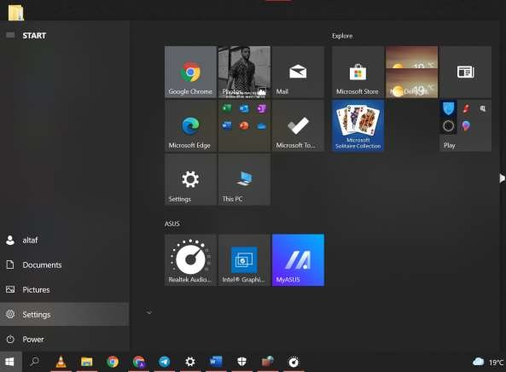

2) Click on windows update and security.

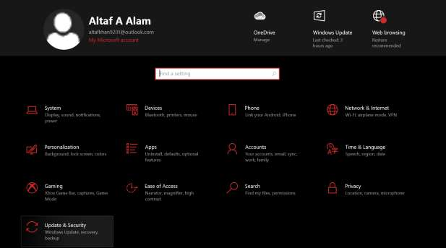

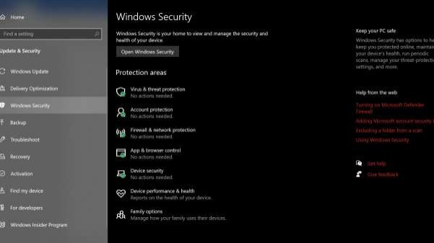3) Click on windows security and then on Firewall and network protection.

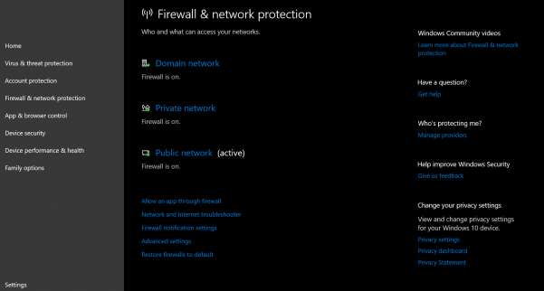

4) Open up firewall and network security and click on public network

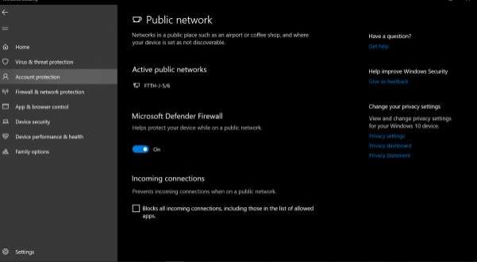5) Now to configure firewall and network: slide on the slider of Microsoft Defender Firewall.

* **Window Defender Fireball with Advanced settings.**

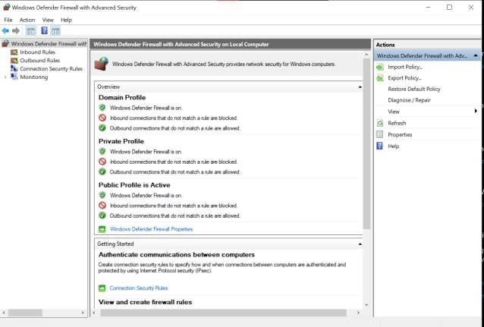

* **Connection Security Rules**
* Connection security involves the authentication of two computers before they begin communications and the securing of information sent between two computers. Windows Firewall with Advanced Security uses Internet Protocol security (IPsec) to achieve connection security by using key exchange, authentication, data integrity, and, optionally, data encryption.
* Connection security rules use IPsec to secure traffic while it crosses the network. We use connection security rules to specify that connections between two computers must be authenticated or encrypted. we have to create a firewall rule to allow network traffic protected by a connection security rule.

**DEMONSTRATE HOW TO PROVIDE SECURE DATA STORAGE, SECURE DATA TRANSMISSION AND FOR CREATING DIGITAL SIGNATURES USING TOOL GNUPG.**

1. Click File->New Certificate:

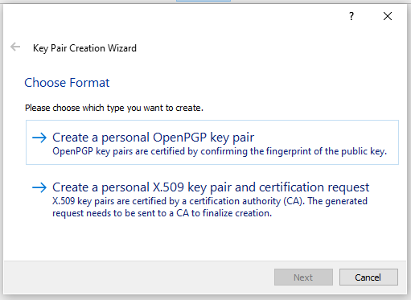

1. Choose and create a personal OpenPGP key pair. It will prompt to enter name and email.

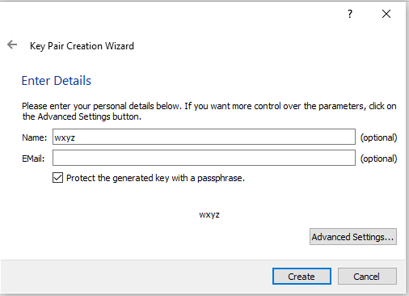

1. Click Advanced Settings and choose appropriate key and key size. After this step key will be created.

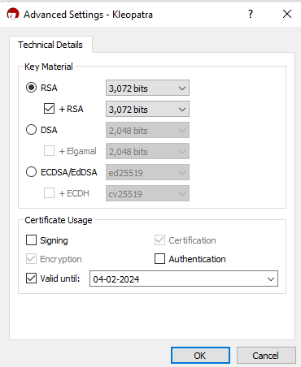

1. Create a text file mail_txt and add some content to it.

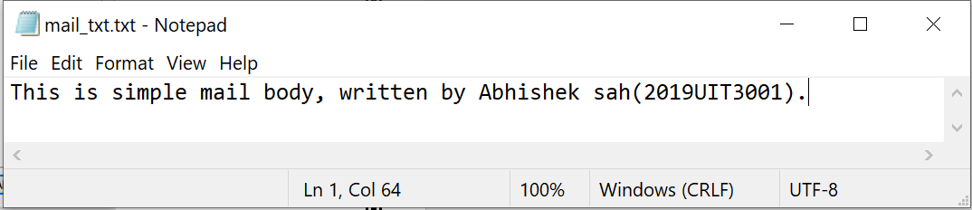

1. Click on Sign/Encrypt Files and select the text file created in the step above. Select the keys and the path to store the encrypted file.

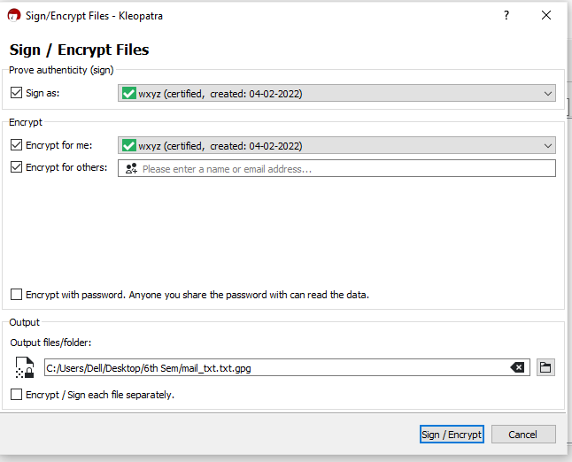

1. Click on Sign/Encrypt and click on finish.

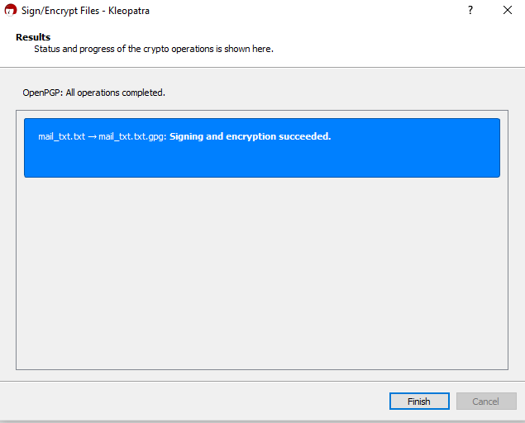

1. Now open the encrypted file to see the encrypted message.

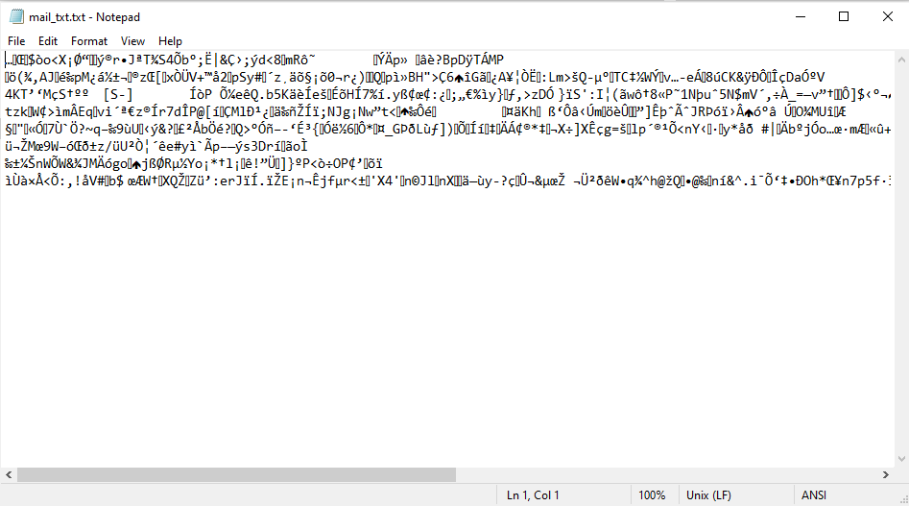

1. Now click on Decrypt/verify and select the encrypted file.

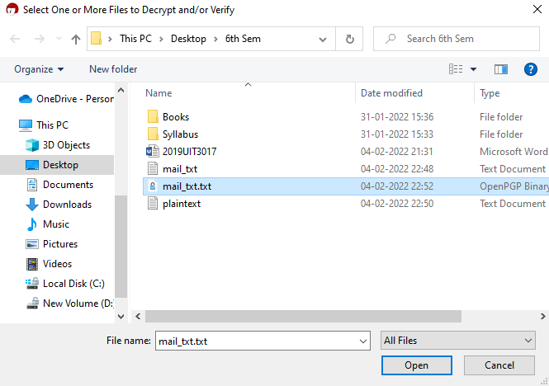

1. Select the path to store the decrypted file.

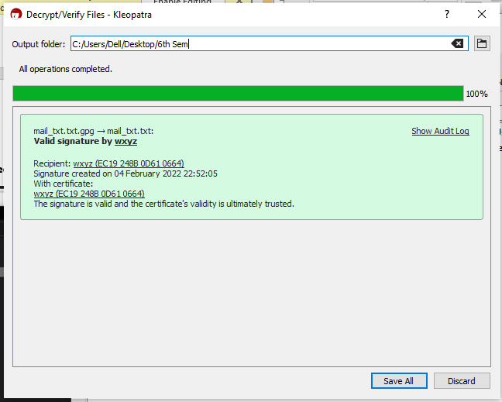

1. Open the decrypted will and it will have same content as the original file. So Encryption and Decryption is successful.



**IMPLEMENT MD5 ALGORITHM**

**MD5.h**

#ifndef md5_h

#define md5_h

#include <cstring>

#include <iostream>

**class** MD5

{

**public**:

**typedef** **unsigned** **int** size_type; // must be 32bit

MD5();

MD5(**const** std::string& text);

**void** update(**const** **unsigned** **char** *buf, size_type length);

**void** update(**const** **char** *buf, size_type length);

MD5& finalize();

std::string hexdigest() **const**;

**friend** std::ostream& **operator**<<(std::ostream&, MD5 md5);

**private**:

**void** init();

**typedef** **unsigned** **char** uint1; // 8bit

**typedef** **unsigned** **int** uint4; // 32bit

**enum** {blocksize = 64}; // VC6 won't eat a const static int here

**void** transform(**const** uint1 block[blocksize]);

**static** **void** decode(uint4 output[], **const** uint1 input[], size_type len);

**static** **void** encode(uint1 output[], **const** uint4 input[], size_type len);

**bool** finalized;

uint1 buffer[blocksize];

uint4 count[2]; // 64bit counter for number of bits (lo, hi)

uint4 state[4]; // digest so far

uint1 digest[16]; // the result

// low level logic operations

**static** **inline** uint4 F(uint4 x, uint4 y, uint4 z);

**static** **inline** uint4 G(uint4 x, uint4 y, uint4 z);

**static** **inline** uint4 H(uint4 x, uint4 y, uint4 z);

**static** **inline** uint4 I(uint4 x, uint4 y, uint4 z);

**static** **inline** uint4 rotate_left(uint4 x, **int** n);

**static** **inline** **void** FF(uint4 &a, uint4 b, uint4 c, uint4 d, uint4 x, uint4 s, uint4 ac);

**static** **inline** **void** GG(uint4 &a, uint4 b, uint4 c, uint4 d, uint4 x, uint4 s, uint4 ac);

**static** **inline** **void** HH(uint4 &a, uint4 b, uint4 c, uint4 d, uint4 x, uint4 s, uint4 ac);

**static** **inline** **void** II(uint4 &a, uint4 b, uint4 c, uint4 d, uint4 x, uint4 s, uint4 ac);

};

std::string md5(**const** std::string str);

#endif /* md5_h */

**Main.cpp**

/* interface header */

#include "md5.h"

/* system implementation headers */

#include <cstdio>

// Constants for MD5Transform routine.

#define S11 7

#define S12 12

#define S13 17

#define S14 22

#define S21 5

#define S22 9

#define S23 14

#define S24 20

#define S31 4

#define S32 11

#define S33 16

#define S34 23

#define S41 6

#define S42 10

#define S43 15

#define S44 21

///////////////////////////////////////////////

// F, G, H and I are basic MD5 functions.

**inline** MD5::uint4 MD5::F(uint4 x, uint4 y, uint4 z) {

**return** x&y | ~x&z;

}

**inline** MD5::uint4 MD5::G(uint4 x, uint4 y, uint4 z) {

**return** x&z | y&~z;

}

**inline** MD5::uint4 MD5::H(uint4 x, uint4 y, uint4 z) {

**return** x^y^z;

}

**inline** MD5::uint4 MD5::I(uint4 x, uint4 y, uint4 z) {

**return** y ^ (x | ~z);

}

// rotate_left rotates x left n bits.

**inline** MD5::uint4 MD5::rotate_left(uint4 x, **int** n) {

**return** (x << n) | (x >> (32-n));

}

// FF, GG, HH, and II transformations for rounds 1, 2, 3, and 4.

// Rotation is separate from addition to prevent recomputation.

**inline** **void** MD5::FF(uint4 &a, uint4 b, uint4 c, uint4 d, uint4 x, uint4 s, uint4 ac) {

a = rotate_left(a+ F(b,c,d) + x + ac, s) + b;

}

**inline** **void** MD5::GG(uint4 &a, uint4 b, uint4 c, uint4 d, uint4 x, uint4 s, uint4 ac) {

a = rotate_left(a + G(b,c,d) + x + ac, s) + b;

}

**inline** **void** MD5::HH(uint4 &a, uint4 b, uint4 c, uint4 d, uint4 x, uint4 s, uint4 ac) {

a = rotate_left(a + H(b,c,d) + x + ac, s) + b;

}

**inline** **void** MD5::II(uint4 &a, uint4 b, uint4 c, uint4 d, uint4 x, uint4 s, uint4 ac) {

a = rotate_left(a + I(b,c,d) + x + ac, s) + b;

}

//////////////////////////////////////////////

// default ctor, just initailize

MD5::MD5()

{

init();

}

// nifty shortcut ctor, compute MD5 for string and finalize it right away

MD5::MD5(**const** std::string &text)

{

init();

update(text.c_str(), text.length());

finalize();

}

//////////////////////////////

**void** MD5::init()

{

finalized=**false**;

count[0] = 0;

count[1] = 0;

// load magic initialization constants.

state[0] = 0x67452301;

state[1] = 0xefcdab89;

state[2] = 0x98badcfe;

state[3] = 0x10325476;

}

//////////////////////////////

// decodes input (unsigned char) into output (uint4). Assumes len is a multiple of 4.

**void** MD5::decode(uint4 output[], **const** uint1 input[], size_type len)

{

**for** (**unsigned** **int** i = 0, j = 0; j < len; i++, j += 4)

output[i] = ((uint4)input[j]) | (((uint4)input[j+1]) << 8) |

(((uint4)input[j+2]) << 16) | (((uint4)input[j+3]) << 24);

}

//////////////////////////////

// encodes input (uint4) into output (unsigned char). Assumes len is

// a multiple of 4.

**void** MD5::encode(uint1 output[], **const** uint4 input[], size_type len)

{

**for** (size_type i = 0, j = 0; j < len; i++, j += 4) {

output[j] = input[i] & 0xff;

output[j+1] = (input[i] >> 8) & 0xff;

output[j+2] = (input[i] >> 16) & 0xff;

output[j+3] = (input[i] >> 24) & 0xff;

}

}

//////////////////////////////

// apply MD5 algo on a block

**void** MD5::transform(**const** uint1 block[blocksize])

{

uint4 a = state[0], b = state[1], c = state[2], d = state[3], x[16];

decode (x, block, blocksize);

/* Round 1 */

FF (a, b, c, d, x[ 0], S11, 0xd76aa478); /* 1 */

FF (d, a, b, c, x[ 1], S12, 0xe8c7b756); /* 2 */

FF (c, d, a, b, x[ 2], S13, 0x242070db); /* 3 */

FF (b, c, d, a, x[ 3], S14, 0xc1bdceee); /* 4 */

FF (a, b, c, d, x[ 4], S11, 0xf57c0faf); /* 5 */

FF (d, a, b, c, x[ 5], S12, 0x4787c62a); /* 6 */

FF (c, d, a, b, x[ 6], S13, 0xa8304613); /* 7 */

FF (b, c, d, a, x[ 7], S14, 0xfd469501); /* 8 */

FF (a, b, c, d, x[ 8], S11, 0x698098d8); /* 9 */

FF (d, a, b, c, x[ 9], S12, 0x8b44f7af); /* 10 */

FF (c, d, a, b, x[10], S13, 0xffff5bb1); /* 11 */

FF (b, c, d, a, x[11], S14, 0x895cd7be); /* 12 */

FF (a, b, c, d, x[12], S11, 0x6b901122); /* 13 */

FF (d, a, b, c, x[13], S12, 0xfd987193); /* 14 */

FF (c, d, a, b, x[14], S13, 0xa679438e); /* 15 */

FF (b, c, d, a, x[15], S14, 0x49b40821); /* 16 */

/* Round 2 */

GG (a, b, c, d, x[ 1], S21, 0xf61e2562); /* 17 */

GG (d, a, b, c, x[ 6], S22, 0xc040b340); /* 18 */

GG (c, d, a, b, x[11], S23, 0x265e5a51); /* 19 */

GG (b, c, d, a, x[ 0], S24, 0xe9b6c7aa); /* 20 */

GG (a, b, c, d, x[ 5], S21, 0xd62f105d); /* 21 */

GG (d, a, b, c, x[10], S22, 0x2441453); /* 22 */

GG (c, d, a, b, x[15], S23, 0xd8a1e681); /* 23 */

GG (b, c, d, a, x[ 4], S24, 0xe7d3fbc8); /* 24 */

GG (a, b, c, d, x[ 9], S21, 0x21e1cde6); /* 25 */

GG (d, a, b, c, x[14], S22, 0xc33707d6); /* 26 */

GG (c, d, a, b, x[ 3], S23, 0xf4d50d87); /* 27 */

GG (b, c, d, a, x[ 8], S24, 0x455a14ed); /* 28 */

GG (a, b, c, d, x[13], S21, 0xa9e3e905); /* 29 */

GG (d, a, b, c, x[ 2], S22, 0xfcefa3f8); /* 30 */

GG (c, d, a, b, x[ 7], S23, 0x676f02d9); /* 31 */

GG (b, c, d, a, x[12], S24, 0x8d2a4c8a); /* 32 */

/* Round 3 */

HH (a, b, c, d, x[ 5], S31, 0xfffa3942); /* 33 */

HH (d, a, b, c, x[ 8], S32, 0x8771f681); /* 34 */

HH (c, d, a, b, x[11], S33, 0x6d9d6122); /* 35 */

HH (b, c, d, a, x[14], S34, 0xfde5380c); /* 36 */

HH (a, b, c, d, x[ 1], S31, 0xa4beea44); /* 37 */

HH (d, a, b, c, x[ 4], S32, 0x4bdecfa9); /* 38 */

HH (c, d, a, b, x[ 7], S33, 0xf6bb4b60); /* 39 */

HH (b, c, d, a, x[10], S34, 0xbebfbc70); /* 40 */

HH (a, b, c, d, x[13], S31, 0x289b7ec6); /* 41 */

HH (d, a, b, c, x[ 0], S32, 0xeaa127fa); /* 42 */

HH (c, d, a, b, x[ 3], S33, 0xd4ef3085); /* 43 */

HH (b, c, d, a, x[ 6], S34, 0x4881d05); /* 44 */

HH (a, b, c, d, x[ 9], S31, 0xd9d4d039); /* 45 */

HH (d, a, b, c, x[12], S32, 0xe6db99e5); /* 46 */

HH (c, d, a, b, x[15], S33, 0x1fa27cf8); /* 47 */

HH (b, c, d, a, x[ 2], S34, 0xc4ac5665); /* 48 */

/* Round 4 */

II (a, b, c, d, x[ 0], S41, 0xf4292244); /* 49 */

II (d, a, b, c, x[ 7], S42, 0x432aff97); /* 50 */

II (c, d, a, b, x[14], S43, 0xab9423a7); /* 51 */

II (b, c, d, a, x[ 5], S44, 0xfc93a039); /* 52 */

II (a, b, c, d, x[12], S41, 0x655b59c3); /* 53 */

II (d, a, b, c, x[ 3], S42, 0x8f0ccc92); /* 54 */

II (c, d, a, b, x[10], S43, 0xffeff47d); /* 55 */

II (b, c, d, a, x[ 1], S44, 0x85845dd1); /* 56 */

II (a, b, c, d, x[ 8], S41, 0x6fa87e4f); /* 57 */

II (d, a, b, c, x[15], S42, 0xfe2ce6e0); /* 58 */

II (c, d, a, b, x[ 6], S43, 0xa3014314); /* 59 */

II (b, c, d, a, x[13], S44, 0x4e0811a1); /* 60 */

II (a, b, c, d, x[ 4], S41, 0xf7537e82); /* 61 */

II (d, a, b, c, x[11], S42, 0xbd3af235); /* 62 */

II (c, d, a, b, x[ 2], S43, 0x2ad7d2bb); /* 63 */

II (b, c, d, a, x[ 9], S44, 0xeb86d391); /* 64 */

state[0] += a;

state[1] += b;

state[2] += c;

state[3] += d;

// Zeroize sensitive information.

memset(x, 0, **sizeof** x);

}

//////////////////////////////

// MD5 block update operation. Continues an MD5 message-digest

// operation, processing another message block

**void** MD5::update(**const** **unsigned** **char** input[], size_type length)

{

// compute number of bytes mod 64

size_type index = count[0] / 8 % blocksize;

// Update number of bits

**if** ((count[0] += (length << 3)) < (length << 3))

count[1]++;

count[1] += (length >> 29);

// number of bytes we need to fill in buffer

size_type firstpart = 64 - index;

size_type i;

// transform as many times as possible.

**if** (length >= firstpart)

{

// fill buffer first, transform

memcpy(&buffer[index], input, firstpart);

transform(buffer);

// transform chunks of blocksize (64 bytes)

**for** (i = firstpart; i + blocksize <= length; i += blocksize)

transform(&input[i]);

index = 0;

}

**else**

i = 0;

// buffer remaining input

memcpy(&buffer[index], &input[i], length-i);

}

//////////////////////////////

// for convenience provide a verson with signed char

**void** MD5::update(**const** **char** input[], size_type length)

{

update((**const** **unsigned** **char**\*)input, length);

}

//////////////////////////////

// MD5 finalization. Ends an MD5 message-digest operation, writing the

// the message digest and zeroizing the context.

MD5& MD5::finalize()

{

**static** **unsigned** **char** padding[64] = {

0x80, 0, 0, 0, 0, 0, 0, 0, 0, 0, 0, 0, 0, 0, 0, 0, 0, 0, 0, 0, 0, 0,

0, 0, 0, 0, 0, 0, 0, 0, 0, 0, 0, 0, 0, 0, 0, 0, 0, 0, 0, 0, 0, 0, 0,

0, 0, 0, 0, 0, 0, 0, 0, 0, 0, 0, 0, 0, 0, 0, 0, 0, 0, 0

};

**if** (!finalized) {

// Save number of bits

**unsigned** **char** bits[8];

encode(bits, count, 8);

// pad out to 56 mod 64.

size_type index = count[0] / 8 % 64;

size_type padLen = (index < 56) ? (56 - index) : (120 - index);

update(padding, padLen);

// Append length (before padding)

update(bits, 8);

// Store state in digest

encode(digest, state, 16);

// Zeroize sensitive information.

memset(buffer, 0, **sizeof** buffer);

memset(count, 0, **sizeof** count);

finalized=**true**;

}

**return** \***this**;

}

//////////////////////////////

// return hex representation of digest as string

std::string MD5::hexdigest() **const**

{

**if** (!finalized)

**return** "";

**char** buf[33];

**for** (**int** i=0; i<16; i++)

sprintf(buf+i*2, "%02x", digest[i]);

buf[32]=0;

**return** std::string(buf);

}

std::ostream& **operator**<<(std::ostream& out, MD5 md5)

{

**return** out << md5.hexdigest();

}

std::string md5(**const** std::string str)

{

MD5 md5 = MD5(str);

**return** md5.hexdigest();

}

**using** std::cout; **using** std::endl;

**int** main(**int** argc, **char** *argv[])

{

cout << "MD5 of 'information': " << md5("information") << endl;

**return** 0;

}

**OUTPUT**

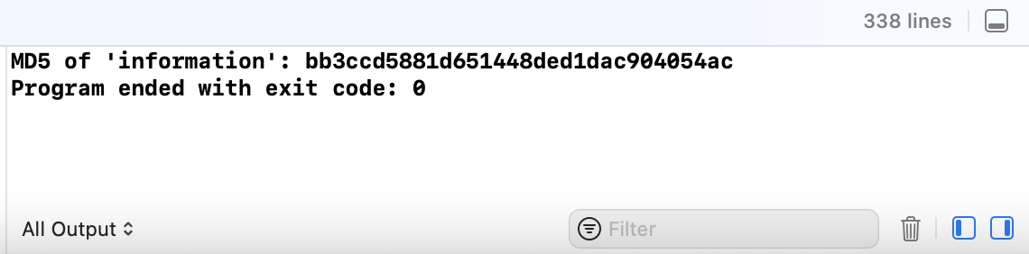

**IMPLEMENT SHA256 ALGORITHM**

**SHA256.h**

#ifndef SHA256_H

#define SHA256_H

#include <string>

using namespace std;

class SHA256

{

protected:

    typedef unsigned char uint8;

    typedef unsigned int uint32;

    typedef unsigned long long uint64;

    const static uint32 sha256_k[];

    static const unsigned int SHA224_256_BLOCK_SIZE = (512/8);

public:

    void init();

    void update(const unsigned char *message, unsigned int len);

    void final(unsigned char *digest);

    static const unsigned int DIGEST_SIZE = ( 256 / 8);

protected:

    void transform(const unsigned char *message, unsigned int block_nb);

    unsigned int m_tot_len;

    unsigned int m_len;

    unsigned char m_block[2*SHA224_256_BLOCK_SIZE];

    uint32 m_h[8];

};

string sha256(string input);

#define SHA2_SHFR(x, n)    (x >> n)

#define SHA2_ROTR(x, n)   ((x >> n) | (x << ((sizeof(x) << 3) - n)))

#define SHA2_ROTL(x, n)   ((x << n) | (x >> ((sizeof(x) << 3) - n)))

#define SHA2_CH(x, y, z)  ((x & y) ^ (~x & z))

#define SHA2_MAJ(x, y, z) ((x & y) ^ (x & z) ^ (y & z))

#define SHA256_F1(x) (SHA2_ROTR(x,  2) ^ SHA2_ROTR(x, 13) ^ SHA2_ROTR(x, 22))

#define SHA256_F2(x) (SHA2_ROTR(x,  6) ^ SHA2_ROTR(x, 11) ^ SHA2_ROTR(x, 25))

#define SHA256_F3(x) (SHA2_ROTR(x,  7) ^ SHA2_ROTR(x, 18) ^ SHA2_SHFR(x,  3))

#define SHA256_F4(x) (SHA2_ROTR(x, 17) ^ SHA2_ROTR(x, 19) ^ SHA2_SHFR(x, 10))

#define SHA2_UNPACK32(x, str)                 \

{                                             \

    *((str) + 3) = (uint8) ((x)      );       \

    *((str) + 2) = (uint8) ((x) >>  8);       \

    *((str) + 1) = (uint8) ((x) >> 16);       \

    *((str) + 0) = (uint8) ((x) >> 24);       \

}

#define SHA2_PACK32(str, x)                   \

{                                             \

    *(x) =   ((uint32) *((str) + 3)      )    \

           | ((uint32) *((str) + 2) <<  8)    \

           | ((uint32) *((str) + 1) << 16)    \

           | ((uint32) *((str) + 0) << 24);   \

}

#endif

SHA256.cpp

#include <bits/stdc++.h>

#include <fstream>

#include "sha256.h"

using namespace std;

const unsigned int SHA256::sha256_k[64] = //UL = uint32

            {0x428a2f98, 0x71374491, 0xb5c0fbcf, 0xe9b5dba5,

             0x3956c25b, 0x59f111f1, 0x923f82a4, 0xab1c5ed5,

             0xd807aa98, 0x12835b01, 0x243185be, 0x550c7dc3,

             0x72be5d74, 0x80deb1fe, 0x9bdc06a7, 0xc19bf174,

             0xe49b69c1, 0xefbe4786, 0x0fc19dc6, 0x240ca1cc,

             0x2de92c6f, 0x4a7484aa, 0x5cb0a9dc, 0x76f988da,

             0x983e5152, 0xa831c66d, 0xb00327c8, 0xbf597fc7,

             0xc6e00bf3, 0xd5a79147, 0x06ca6351, 0x14292967,

             0x27b70a85, 0x2e1b2138, 0x4d2c6dfc, 0x53380d13,

             0x650a7354, 0x766a0abb, 0x81c2c92e, 0x92722c85,

             0xa2bfe8a1, 0xa81a664b, 0xc24b8b70, 0xc76c51a3,

             0xd192e819, 0xd6990624, 0xf40e3585, 0x106aa070,

             0x19a4c116, 0x1e376c08, 0x2748774c, 0x34b0bcb5,

             0x391c0cb3, 0x4ed8aa4a, 0x5b9cca4f, 0x682e6ff3,

             0x748f82ee, 0x78a5636f, 0x84c87814, 0x8cc70208,

             0x90befffa, 0xa4506ceb, 0xbef9a3f7, 0xc67178f2};

void SHA256::transform(const unsigned char *message, unsigned int block_nb)

{

    uint32 w[64];

    uint32 wv[8];

    uint32 t1, t2;

    const unsigned char *sub_block;

    int i;

    int j;

    for (i = 0; i < (int) block_nb; i++) {

        sub_block = message + (i << 6);

        for (j = 0; j < 16; j++) {

            SHA2_PACK32(&sub_block[j << 2], &w[j]);

        }

        for (j = 16; j < 64; j++) {

            w[j] =  SHA256_F4(w[j -  2]) + w[j -  7] + SHA256_F3(w[j - 15]) + w[j - 16];

        }

        for (j = 0; j < 8; j++) {

            wv[j] = m_h[j];

        }

        for (j = 0; j < 64; j++) {

            t1 = wv[7] + SHA256_F2(wv[4]) + SHA2_CH(wv[4], wv[5], wv[6])

                + sha256_k[j] + w[j];

            t2 = SHA256_F1(wv[0]) + SHA2_MAJ(wv[0], wv[1], wv[2]);

            wv[7] = wv[6];

            wv[6] = wv[5];

            wv[5] = wv[4];

            wv[4] = wv[3] + t1;

            wv[3] = wv[2];

            wv[2] = wv[1];

            wv[1] = wv[0];

            wv[0] = t1 + t2;

        }

        for (j = 0; j < 8; j++) {

            m_h[j] += wv[j];

        }

    }

}

void SHA256::init()

{

    m_h[0] = 0x6a09e667;

    m_h[1] = 0xbb67ae85;

    m_h[2] = 0x3c6ef372;

    m_h[3] = 0xa54ff53a;

    m_h[4] = 0x510e527f;

    m_h[5] = 0x9b05688c;

    m_h[6] = 0x1f83d9ab;

    m_h[7] = 0x5be0cd19;

    m_len = 0;

    m_tot_len = 0;

}

void SHA256::update(const unsigned char *message, unsigned int len)

{

    unsigned int block_nb;

    unsigned int new_len, rem_len, tmp_len;

    const unsigned char *shifted_message;

    tmp_len = SHA224_256_BLOCK_SIZE - m_len;

    rem_len = len < tmp_len ? len : tmp_len;

    memcpy(&m_block[m_len], message, rem_len);

    if (m_len + len < SHA224_256_BLOCK_SIZE) {

        m_len += len;

        return;

    }

    new_len = len - rem_len;

    block_nb = new_len / SHA224_256_BLOCK_SIZE;

    shifted_message = message + rem_len;

    transform(m_block, 1);

    transform(shifted_message, block_nb);

    rem_len = new_len % SHA224_256_BLOCK_SIZE;

    memcpy(m_block, &shifted_message[block_nb << 6], rem_len);

    m_len = rem_len;

    m_tot_len += (block_nb + 1) << 6;

}

void SHA256::final(unsigned char *digest)

{

    unsigned int block_nb;

    unsigned int pm_len;

    unsigned int len_b;

    int i;

    block_nb = (1 + ((SHA224_256_BLOCK_SIZE - 9)

                     < (m_len % SHA224_256_BLOCK_SIZE)));

    len_b = (m_tot_len + m_len) << 3;

    pm_len = block_nb << 6;

    memset(m_block + m_len, 0, pm_len - m_len);

    m_block[m_len] = 0x80;

    SHA2_UNPACK32(len_b, m_block + pm_len - 4);

    transform(m_block, block_nb);

    for (i = 0 ; i < 8; i++) {

        SHA2_UNPACK32(m_h[i], &digest[i << 2]);

    }

}

string sha256(string input)

{

    unsigned char digest[SHA256::DIGEST_SIZE];

    memset(digest,0,SHA256::DIGEST_SIZE);

    SHA256 ctx = SHA256();

    ctx.init();

    ctx.update( (unsigned char*)input.c_str(), input.length());

    ctx.final(digest);

    char buf[2*SHA256::DIGEST_SIZE+1];

    buf[2*SHA256::DIGEST_SIZE] = 0;

    for (int i = 0; i < SHA256::DIGEST_SIZE; i++)

        sprintf(buf+i*2, "%02x", digest[i]);

    return string(buf);

}

int main(int argc, char *argv[])

{

    string input = "secret";

    string output1 = sha256(input);

    cout << "SHA256('"<< input << "') : " << output1 << endl;

    return 0;

}

OUTPUT

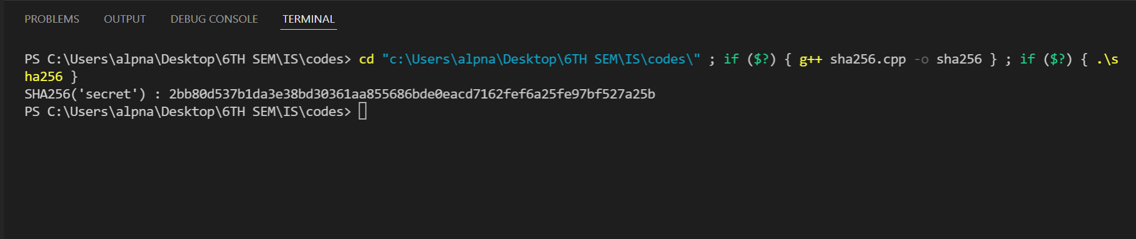

**PLOT AN ELLIPTIC CURVE OVER FINITE FIELD. CHECK WHETHER THE POINTS LIES ON THE ELLIPTIC CURVE OR NOT.**

import numpy as np  
import matplotlib.pyplot as plt  
  
def ecc(x, p, A, B):  
 assert (4*A**3 + 27*B**2) % p!= 0  
 return (x**3 + A*x + B) % p  
  
# Find the elements in x^2 that are equal to elements in y^2, which in finite field is to find sqrt  
def sqrt_f(x, y2, p):  
 x2 = x**2 % p  
 y = [(i, *y_i) for i, y_i in enumerate([np.where(y2_i == x2)[0] for y2_i in y2]) if y_i.size > 0]  
 return y  
  
  
# Order  
p = 31  
x = np.array(range(0, p))  
  
A = -5  
B = 8  
  
x2 = x**2 % p  
y2 = ecc(x, p, A, B)  
  
# Compute the sqrt of the elliptic curve for plotting  
y = sqrt_f(x, y2, p)  
  
fig = plt.figure(dpi=100)  
for y_p in y:  
 [plt.scatter(y_p[0], i, c='b') for i in y_p[1:]]  
  
# Number of points and +1 for point at infinity  
len(sum([y_p[1:] for y_p in y], ())) + 1  
  
print(*['[x:{}, y:{}]'.format(y_p[0], y_p[1:]) for y_p in y])  
  
plt.show()

**OUTPUT**

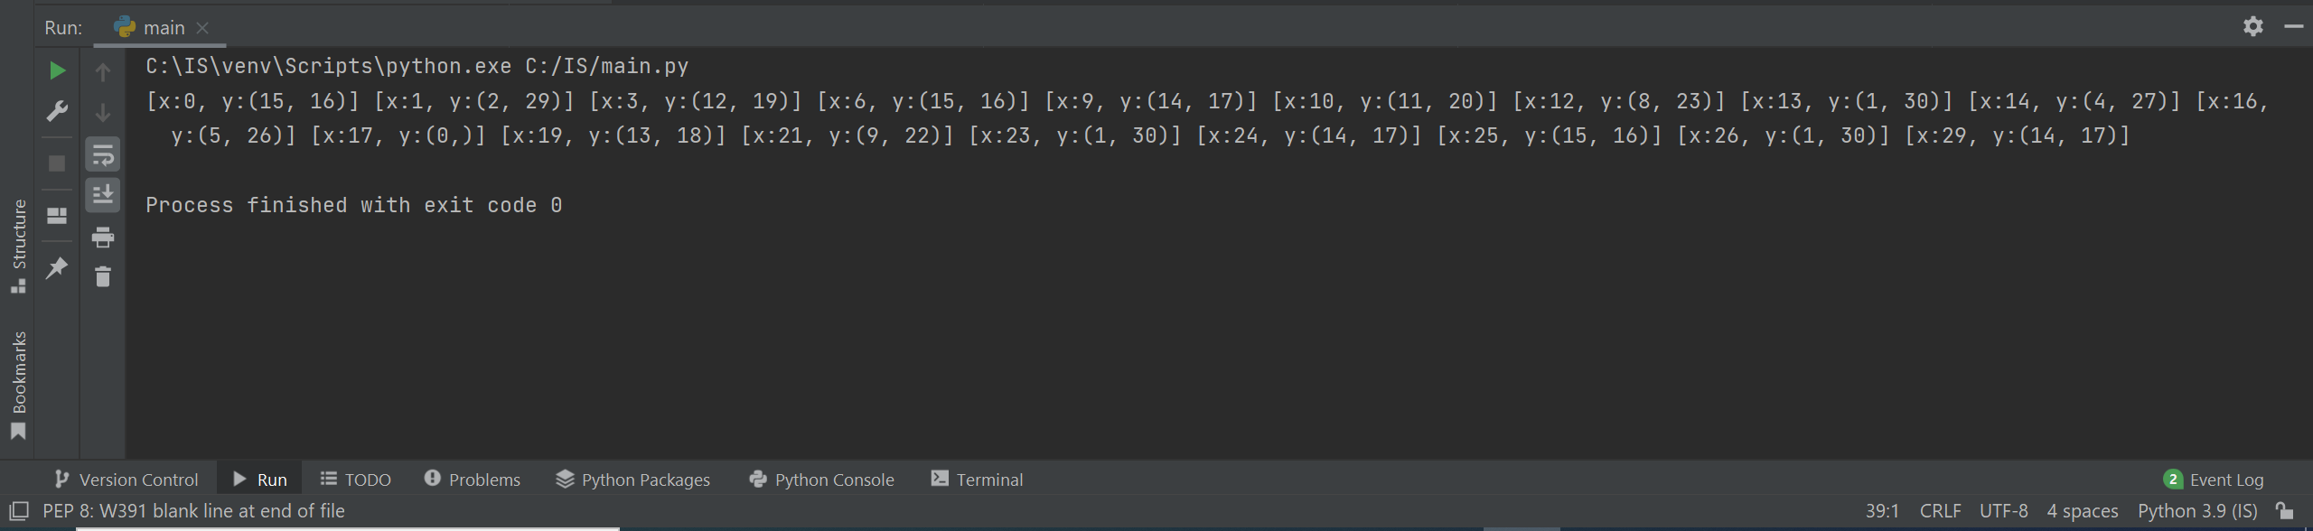

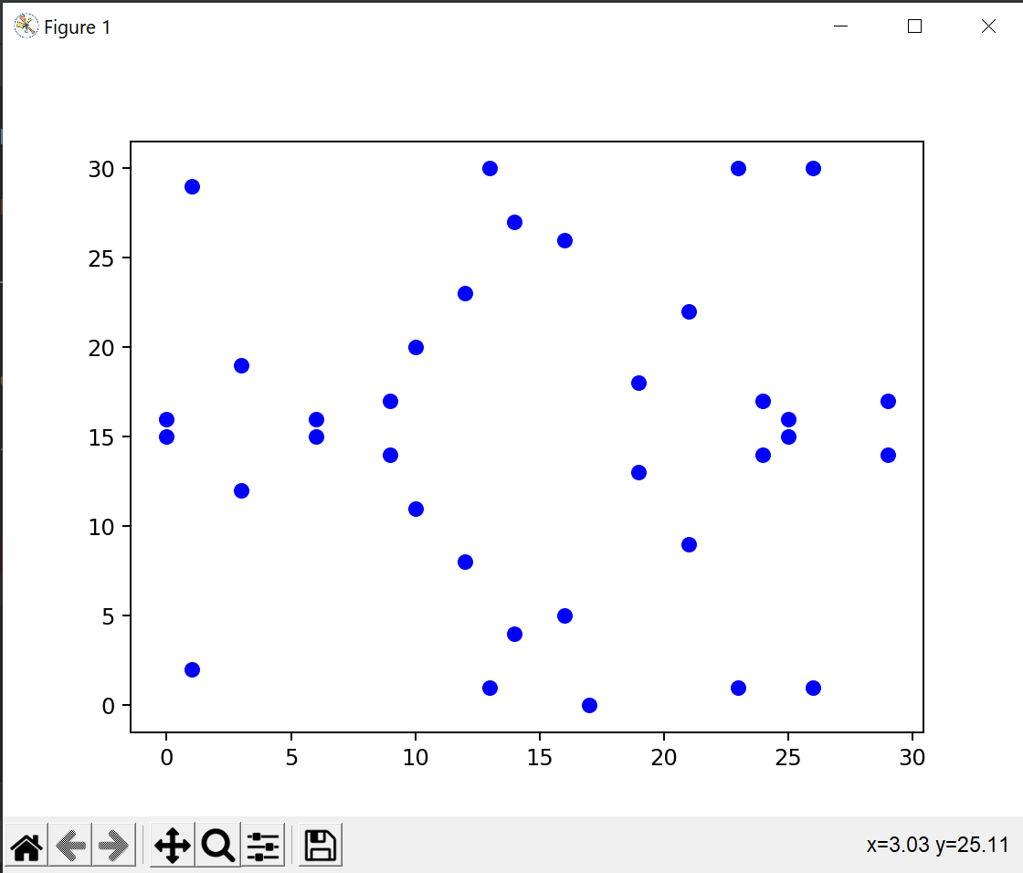

PERFORM THE ELLIPTIC CURVE OPERATIONS LIKE ADDITION AND MULTIPLICATION OF TWO POINTS AND FIND THE INVERSE OF A POINT ALSO.

import numpy as np  
import matplotlib.pyplot as plt  
  
  
def ecc(x, p, A, B):  
 assert (4 * A ** 3 + 27 * B ** 2) % p != 0  
 return (x ** 3 + A * x + B) % p  
  
  
# Find the elements in x^2 that are equal to elements in y^2, which in finite field is to find sqrt  
def sqrt_f(x, y2, p):  
 x2 = x ** 2 % p  
 y = [(i, *y_i) for i, y_i in enumerate([np.where(y2_i == x2)[0] for y2_i in y2]) if y_i.size > 0]  
 return y  
  
  
# Order  
p = 31  
x = np.array(range(0, p))  
  
A = -5  
B = 8  
  
x2 = x ** 2 % p  
y2 = ecc(x, p, A, B)  
  
# Compute the sqrt of the elliptic curve for plotting  
y = sqrt_f(x, y2, p)  
  
fig = plt.figure(dpi=100)  
for y_p in y:  
 [plt.scatter(y_p[0], i, c='b') for i in y_p[1:]]  
  
  
def get_2P(P, p, A, B):  
 x, y = P  
  
 lam = (3 * x ** 2 + A) * eea(2 * y, p) % p  
 nu = (-x ** 3 + A * x + 2 * B) * eea(2 * y, p) % p  
 # n = (x**4 - 2*A*x**2 - 8*B*x + A**2) % p  
 # d = (4 * (x ** 3 + A * x + B)) % p  
 # d = eea(d, p)  
 return (lam ** 2 - 2 * x) % p, (-lam ** 3 + 2 * lam * x - nu) % p  
 # return n * d % p, ecc(n * d % p, p, A, B)  
  
  
def get_PQ(P, Q, p, A, B):  
 x1, y1 = P  
 x2, y2 = Q  
  
 lam = (y2 - y1) * eea((x2 - x1) % p, p) % p  
 nu = (y1 * x2 - y2 * x1) * eea((x2 - x1) % p, p) % p  
  
 return (lam ** 2 - x1 - x2) % p, (-lam ** 3 + lam * (x1 + x2) - nu) % p  
  
  
def sum_on_E(P, Q, p, A, B):  
 # We have a point at infinity  
 if (P == 0):  
 return Q  
 if (Q == 0):  
 return P  
 if (P == Q):  
 if P[0] == 0:  
 # Point at infinity  
 return 0  
 val = get_2P(P, p, A, B)  
 return val  
 else:  
 if P[0] == Q[0]:  
 return 0  
  
 val = get_PQ(P, Q, p, A, B)  
 return val  
  
  
# Extended Euclidean Algorithm for finding inverse of x mod p  
def eea(x, p, debug=False):  
 # Quotient  
 q = int(p / x)  
 # Remainder  
 r = r_old = p % x  
  
 q_s = [q]  
 a_s = [0, 1]  
 i = 0  
 while True:  
 if debug:  
 print(f'{q * x + r} = {q} * {x} + {r}')  
 if i > 1:  
 a_i = (a_s[i - 2] - a_s[i - 1] * q_s[i - 2]) % p  
 a_s.append(a_i)  
 if r == 0:  
 if r_old != 1:  
 assert "No inverse"  
 i = i + 1  
 break  
 r_old = r  
 q = int(x / r)  
 q_s.append(q)  
 r = x % r  
 x = r_old  
 i = i + 1  
  
 a_i = (a_s[i - 2] - a_s[i - 1] * q_s[i - 2]) % p  
 return a_i  
  
  
plt.show()

**OUTPUT**

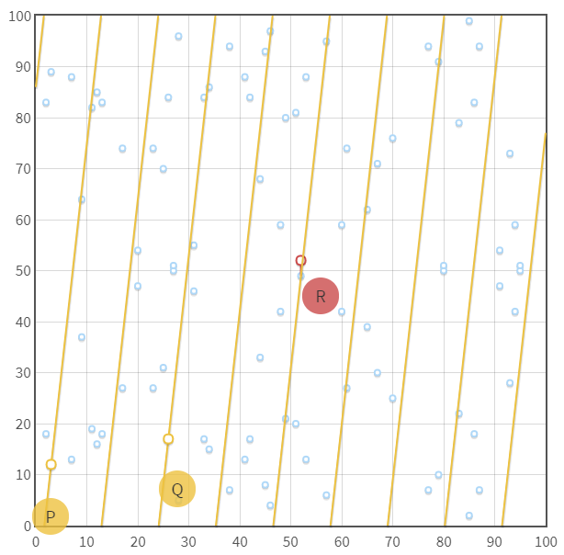



**IMPLEMENT THE RSA DIGITAL SIGNATURE SCHEME**

#include <iostream>

#include<bits/stdc++.h>

using namespace std;

int modu(int b, unsigned int exp, unsigned int m){

int x = 1;

int i;

int power = b % m;

for (i = 0; i < sizeof(int) * 8; i++) {

 int least_bit = 0x00000001 & (exp >> i);

 if (least_bit)

 x = (x * power) % m;

 power = (power * power) % m;

 } return x;

}

int modI(int a, int m)

{

int temp = m;

int y = 0, x = 1;

if (m == 1)

 return 0;

 while (a > 1)

 { int q = a / m;

 int t = m;

 m = a % m, a = t;

 t = y;

 y = x - q * y;

 x = t;

 } if (x < 0)

 x += temp;

 return x;

}

int gcd(int a, int b)

{

if (a == 0 || b == 0)

 return 0;

if (a == b)

 return a;

if (a > b)

 return gcd(a-b, b);

 return gcd(a, b-a);

}

int Prime(int num){

 int flag = 1;

 for(int i=2;i<=sqrt(num);i++)

 {

 if(num%i==0)

 {

 flag = 0;

 return flag;

 }

 }

 return flag;

}

int lcm(int a, int b)

{

 return (a*b)/gcd(a, b);

}

int main(){

int msg; char m;

 cout<<"\n Enter the character to be encrypted: ";

 cin>>m;

msg = (int)m;

 cout<<"\n The corresponding ASCII value of the character is"<<msg;

int p,q, random; int i=0; int a[2];

 srand (time(NULL));

 generate:

 while(i<2){

 random = rand() % 40 + 3;

 if(Prime(random)){

 a[i]=random;

 i++;

 } }

 i=0;p=a[0];q=a[1];

 if(p==q){

 goto generate;

}

 cout<<"\n The Random Prime Numbers are: "<<p<<" and "<<q;

int n; n = p*q;

int phi = (p-1)*(q-1);

int lambda = lcm(p-1,q-1);

int e;

 vector<int> tot;

 for(int i=3;i<lambda;i++)

 { if(gcd(i,lambda) == 1){

 tot.push_back(i);

 }

}

int size = tot.size();

int ran = rand() % size;

e = tot[ran];

 cout<<"\n The modulus is: "<<n;

 cout<<"\n The phi(n) is: "<<phi;

 cout<<"\n The lambda(n) is:"<<lambda;

 cout<<"\n The toitient is: "<<e;

 cout<<"\n The public key is: ("<<n<<","<<e<<")";

long long int encrypt;

 encrypt = modu(msg,e,n);

 cout<<"\n The Cipher text is: "<<(char)encrypt;

 cout<<"\n The ASCII value of Cipher Text is: "<<encrypt;

long long int d = modI(e,lambda);

 if(d==e){

 cout<<"\n";

 goto generate;

}

 cout<<"\n The private key is: "<<d;

long long int decrypted;

 decrypted = modu(encrypt,d,n);

 cout<<"\n The Decrypted/Plain text is : "<<(char)decrypted;

 cout<<"\n The ASCII value of Plain text is: "<<decrypted;

return 0;

}

**OUTPUT**

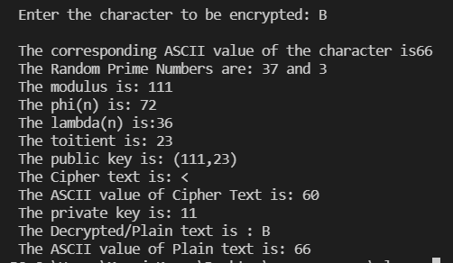

**IMPLEMENT ELGAMAL DIGITAL SIGNATURE SCHEME**

#include<stdio.h>

#include<stdlib.h>

#include<string.h>

int checkIfPrime (int newPrime);

int checkRoot (int newPrime, int newRoot);

int computeYa (int newRoot, int newXa, int newPrime);

int computeInverseK (int userK, int newPrime);

int computeS2 (int inverseK, int userHash, int userXa, int userS1, int newPrime);

int computeV2 (int Ya, int S1, int S2, int newPrime);

int main ()

{

    int p = 0, q = 0, randXa = 0, UserAYa = 0, userS1 = 0, userS2 = 0;

    int primeCheck = 0, primitiveCheck = 0, userInt = 0;

    int hashValue = -1, randK = 0, inverseK = 0;

    char userChoice;

    char userMessage[256];

    int gcd;

    int V1 = 0, V2 = 0;

    printf ("Welcome to the ElGamal digital signature this works with primes up to 17\n\nThe global elements of this signature are a prime q\nand p, which is the primitive root of q\n");

    while (primeCheck == 0)

    {

        printf ("\nEnter a prime number q: ");

        scanf ("%d", &q);

        primeCheck = checkIfPrime (q);

        if (primeCheck == 1)

            printf (" This is in fact prime\n");

        else

        {

            printf (" Whoops, not prime\n");

            primeCheck = 0;

        }

    }

    while (primitiveCheck == 0)

    {

        printf ("\nEnter a primitive root of p: ");

        scanf ("%d", &p);

        primitiveCheck = checkRoot (q, p);

        if (primitiveCheck == 1) printf ("\nThis is in fact a primitive root\n");

        else

        {

            printf ("\nWhoops, not a primitive root\n");

            primeCheck = 0;

        }

    }

    printf ("\n\nNext User A generates a private/public key pair. First your random integer is generated");

    printf ("\nWould you like to enter a number greater than 1 but less than %d, y for yes or n for no: ", q - 1);

    scanf (" %c", &userChoice);

    if (userChoice == 'n')

    {

        while ((randXa <= 1) || (randXa >= q - 1))

        {

        randXa = rand ();

        }

    }

    else

    {

        while (randXa == 0)

        {

        printf ("Enter your random integer: ");

        scanf ("%d", &randXa);

        if ((randXa <= 1) || (randXa >= q - 1))

        randXa = 0;

        }

    }

    printf ("\n\nNext we computer Ya = p^Xa mod q");

    UserAYa = computeYa (p, randXa, q);

    printf ("\nUser A's Ya is %d", UserAYa);

    printf ("\nA's private key Xa is %d, A's public key is {q, p, Ya} {%d,%d,%d}\n",

    randXa, q, p, UserAYa);

    while (getchar () != '\n'); //Clears the buffer

    printf ("\n\nPlease enter your message:");

    scanf ("%[^\n]", userMessage);

    printf ("\nNext we are gonna give the user Message M a hash value m.");

    printf ("\nWould you like to enter one? y/n: ");

    scanf (" %c", &userChoice);

    if (userChoice == 'n')

    {

        while ((hashValue < 0) || (hashValue > q - 1))

        {

        hashValue = rand ();

        }

    }

    else

    {

        while (hashValue == -1)

        {

        printf ("Enter your hash value: ");

        scanf ("%d", &hashValue);

        if ((hashValue < 0) || (hashValue > q - 1)) hashValue = -1;

        }

    }

    printf ("\nThe hash value is %d", hashValue);

    printf ("\n\nA then forms a digital signature as follows");

    while (randK < 1)

    {

        while ((randK < 1) || (randK > q - 1))

        {

        randK = rand ();

        }

        for (int i = 1; i <= randK && i <= (q - 1); i++)

        {

            if ((randK % i == 0) && ((q - 1) % i == 0))

            gcd = i;

        }

        if (gcd != 1)

        randK = 0;

    }

    printf ("\n The a random integer K is generated %d\n", randK);

    printf ("\n Next we compute S1 = p^K mod q\n");

    userS1 = computeYa (p, randK, q);

    printf (" S1 is %d\n", userS1);

    printf ("\n Next we compute K^-1 mod(q-1)");

    inverseK = computeInverseK (randK, q);

    printf ("\n K^-1 is %d because %d*%d mod %d = 1", inverseK, inverseK,

    randK, q - 1);

    printf ("\n\n Next we compute S2 = K^-1(m-XaS1)mod(q-1)");

    userS2 = computeS2 (inverseK, hashValue, randXa, userS1, q);

    printf ("\n S2 is %d because it is %d*(%d - %d*%d)mod(%d) ", userS2,

    inverseK, hashValue, randXa, userS1, q - 1);

    printf ("\n\nThe signature consists of (S1, S2) which are %d , %d", userS1,

    userS2);

    //Verification

    printf ("\nWould you like to verify? y/n: ");

    scanf (" %c", &userChoice);

    if (userChoice == 'y')

    {

        printf ("\n\nTo check first we calculate V1 = p^m mod q");

        V1 = computeYa (p, hashValue, q);

        printf ("\n\nThen we calculate V2 = (Ya^S1 * S1^S2)mod q");

        V2 = computeV2 (UserAYa, userS1, userS2, q);

        printf ("\n\nFinally, we check whether they equal each other");

        if (V1 == V2) printf ("\nThe signature is valid V1 %d == V2 %d\n\n", V1, V2);

        else printf ("\nSignature is invalid V1 %d != V2 %d\n\n", V1, V2);

    }

    return 0;

}

int computeV2 (int Ya, int S1, int S2, int newPrime)

{

    int newV2 = 0;

    long long int exYa = 1, exS1 = 1;

    while (S2 != 0)

    {

        exS1 *= S1;

        --S2;

    }

    while (S1 != 0)

    {

        exYa *= Ya;

        --S1;

    }

    exYa = exYa % newPrime;

    exS1 = exS1 % newPrime;

    newV2 = exYa * exS1;

    newV2 = newV2 % newPrime;

    return newV2;

}

int computeS2 (int inverseK, int userHash, int userXa, int userS1, int newPrime)

{

 int newS2 = 0;

 newS2 = inverseK * (userHash - (userXa * userS1));

 newS2 = newS2 % (newPrime - 1);

 if (newS2 < 0)

    newS2 = newS2 + (newPrime - 1);

 return newS2;

}

int computeInverseK (int userK, int newPrime)

{

 int inverseK = 0;

 int testValue, posValue = 1;

 while (inverseK == 0)

 {

    testValue = (posValue * userK) % (newPrime - 1);

    if (testValue == 1)

    {

        inverseK = posValue;

    }

    else

    {

        posValue++;

    }

 }

 return inverseK;

}

int computeYa (int newRoot, int newXa, int newPrime)

{

 long long int newYa = 1;

 while (newXa != 0)

 {

    newYa *= newRoot;

    --newXa;

 }

 newYa = newYa % newPrime;

 return (int) newYa;

}

// Checks if number is prime

int checkIfPrime (int newPrime)

{

 if (newPrime <= 1)

    return 0;

 if (newPrime > 2)

    for (int factor = 2; factor < newPrime; factor++)

    {

    if (newPrime % factor == 0)

    return 0;

    }

 return 1;

}

int checkRoot (int newPrime, int newRoot)

{

 long long int primeCombo = 0, modCheck = 1;

 int power;

 char result;

 if (newRoot >= newPrime) return 0;

 for (int factor = 1; factor < newPrime; factor++) primeCombo = primeCombo + factor;

 printf ("\n Starting PrimeCombo %d", primeCombo);

 for (int exponent = 1; exponent < newPrime; exponent++)

 {

    power = exponent;

    while (power != 0){modCheck *= (long long int) newRoot; --power;}

    modCheck = modCheck % (long long int) newPrime;

    printf ("\n%d^%d mod %d is %lli", newRoot, exponent, newPrime, modCheck);

    modCheck = 1;

 }

 printf ("\nDid any value repeat?(y for yes or n for no) ");

 scanf (" %c", &result);

 if (result == 'y')

    return 0;

 else

    return 1;

}

**OUTPUT**

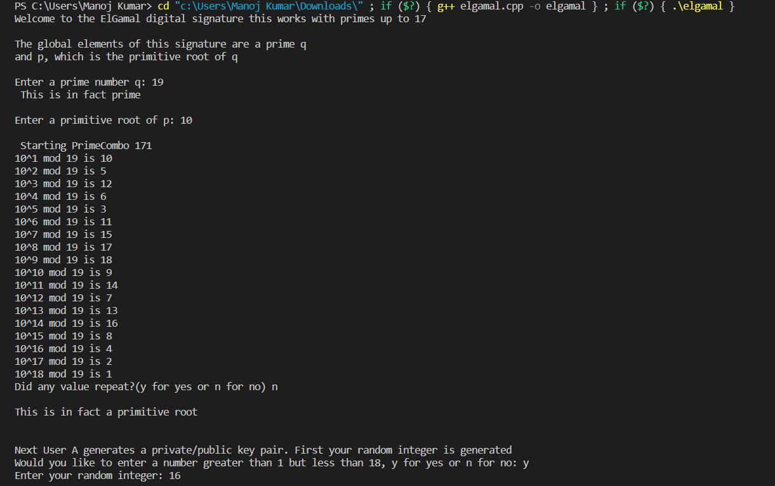

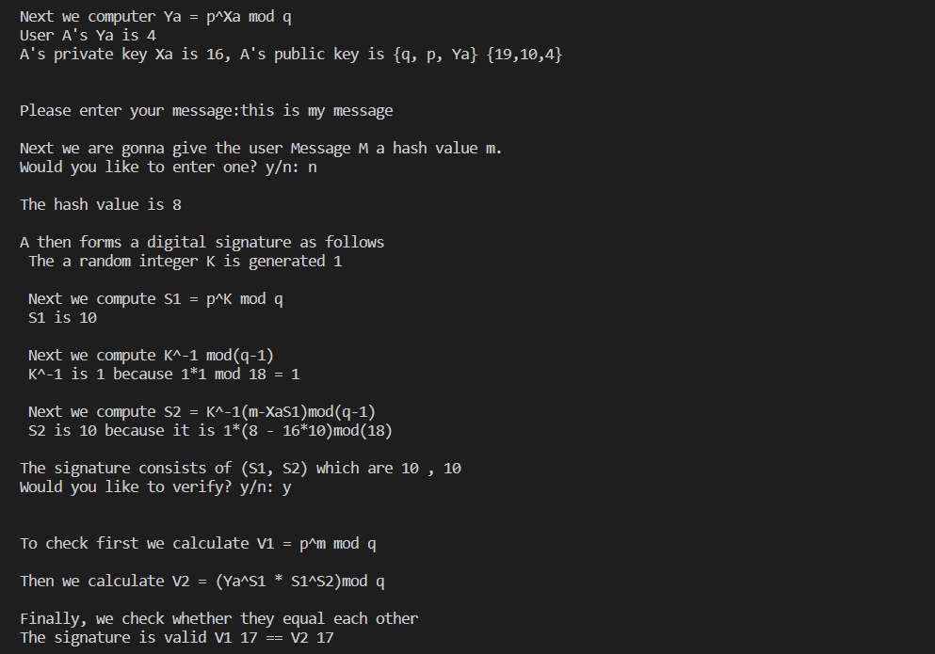

**IMPLEMENT SCHNORR DIGITAL SIGNATURE SCHEME**

#include <bits/stdc++.h>

using namespace std;

#define ld long long

ld ModInv(ld b, ld n)

{

  ld r1 = n, r2 = b, t1 = 0, t2 = 1;

  while (r2 > 0)

  {

    ld q = r1 / r2;

    ld r = r1 - q * r2;

    r1 = r2;

    r2 = r;

    ld t = t1 - q * t2;

    t1 = t2;

    t2 = t;

  }

  if (t1 < 0)

    t1 += n;

  return t1;

}

ld powerLL(ld x, ld n, ld MOD)

{

  ld result = 1;

  while (n)

  {

    if (n & 1)

      result = result * x % MOD;

    n = n / 2;

    x = x * x % MOD;

  }

  return result;

}

ld powerStrings(string sa, string sb, ld MOD)

{

  ld a = 0, b = 0;

  for (int i = 0; i < sa.length(); i++)

    a = (a * 10 + (sa[i] - '0')) % MOD;

  for (int i = 0; i < sb.length(); i++)

    b = (b * 10 + (sb[i] - '0')) % (MOD - 1);

  return powerLL(a, b, MOD);

}

ld mod(string num, ld a)

{

  ld res = 0;

  // One by one process all digits of 'num'

  for (int i = 0; i < num.length(); i++)

    res = (res * 10 + (int)num[i] - '0') % a;

  return res;

}

int main()

{

  ld p, q, e0, d, m, r, MOD;

  cout << "Enter the value of p, q, e0, d, m and r respecitively: ";

  cin >> p >> q >> e0 >> d >> m >> r;

  // 2267 103 2 30 1000 11

  ld a, b, t, bef_v, bef_s1, e1, e2, s1, s2, v;

  e1 = powerStrings(to_string(e0), to_string((p - 1) / q), p);

  if (e1 < 0)

    e1 += p;

  e2 = powerStrings(to_string(e1), to_string(d), p);

  if (e2 < 0)

    e2 += p;

  ////////// For concate  S1 we are finding both components

  a = powerStrings(to_string(e1), to_string(r), p);

  if (a < 0)

    a += p;

  bef_s1 = stoll(to_string(m) + to_string(a), NULL, 10);

  s1 = 200;

  s2 = (r + ((d * s1) % q)) % q;

  //////////////// fro concate V we are finding both components

  a = powerStrings(to_string(e1), to_string(s1), p);

  if (a < 0)

    a += p;

  b = powerStrings(to_string(e2), to_string(s2), p);

  if (b < 0)

    b += p;

  t = (a * b) % p;

  bef_v = stoll(to_string(m) + to_string(t), NULL, 10);

  cout << "e1=" << e1 << "\n";

  cout << "e2=" << e2 << "\n";

  cout << "s2=" << s2 << "\n";

  cout << "bef_s1=" << bef_s1 << "\n";

  cout << "bef_v=" << bef_v << "\n";

}

**OUTPUT**

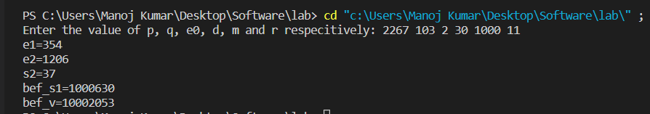

**USING JCRYPT TOOL (OR ANY OTHER EQUIVALENT) TO DEMONSTRATE ASYMMETRIC, SYMMETRIC CRYPTO ALGORITHM**

**ASYMMETRIC ALGORITHM**

* Download Jcrypt tool from Cryptool Website and Install .
* Open Jcrypt Software and Click on NEW text editior, type the text information into it

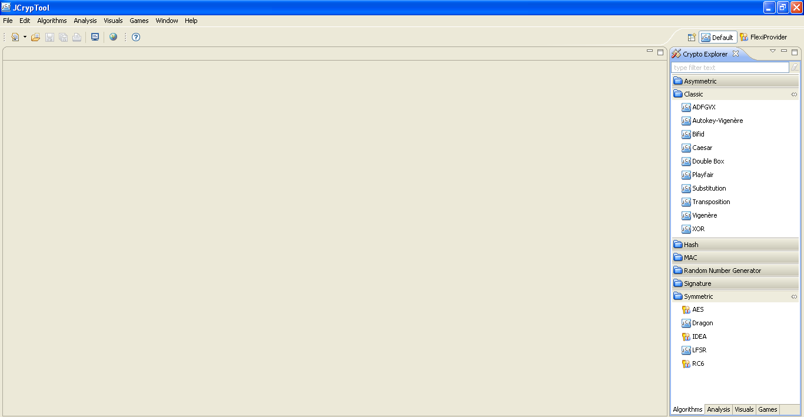

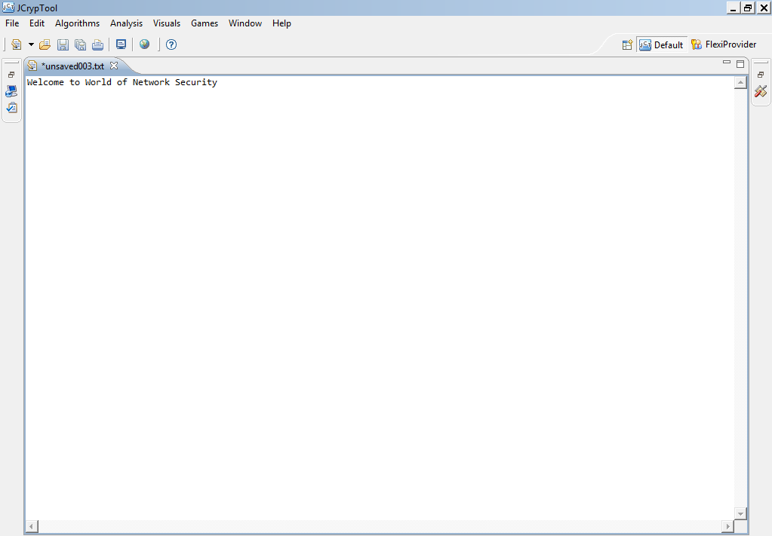

* Click on the Algorithm menu bar and Select Asymmetric algorithm RSA for encryption.
* Click create a New KeyPair and type in the contact name[xxxxx] and enter the password and confirm password, then Click finish again.

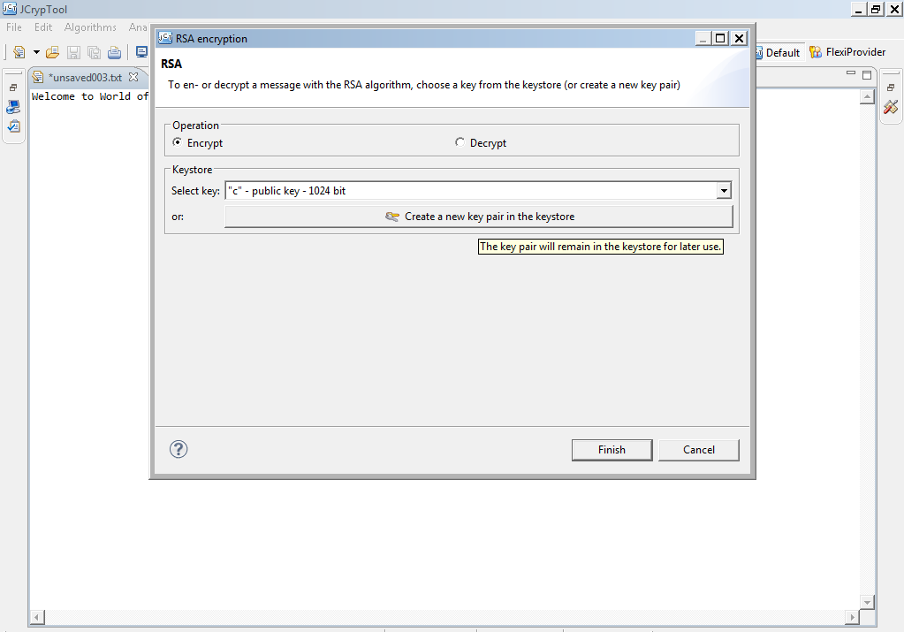

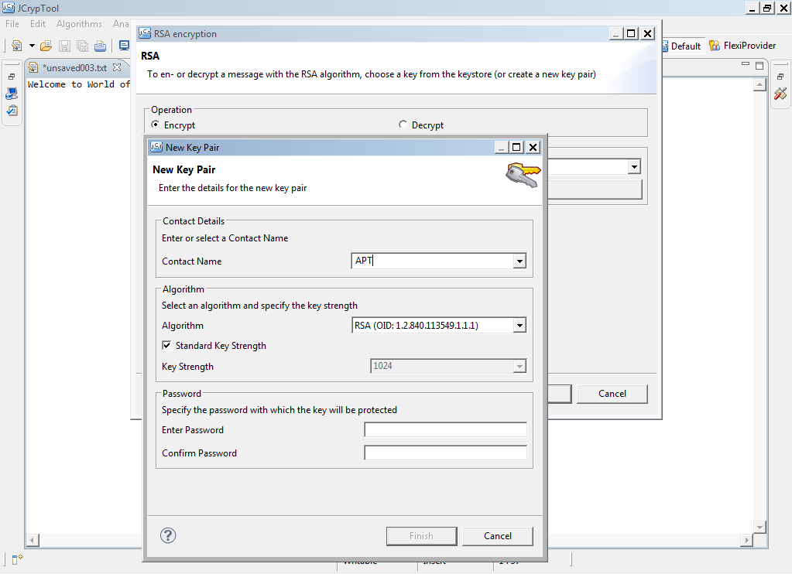

* Now you can see RSA output bin file is generated.

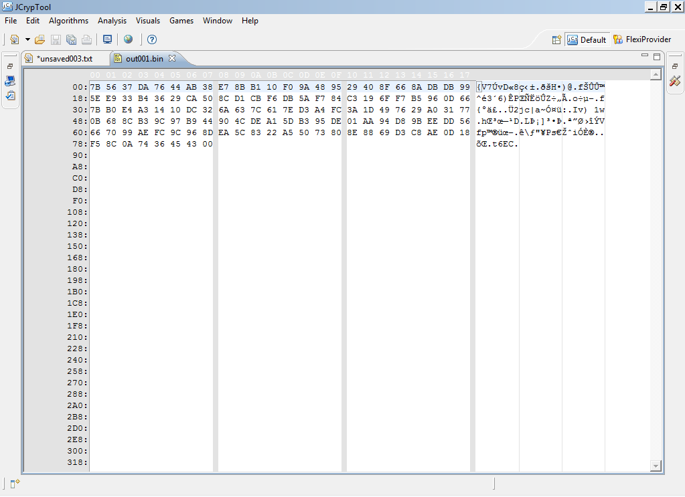

* The same output bin file to decrypt select RSA Algorithm and Click on Decrypt, Select keyname you have declared earlier and Click Finish.
* Enter the password to Decrypt and see the output with original Decrypted text on the Screen.

**SYMMETRIC ALGORITHM**

* Click on Algorithm Menu bar Select Symmetric◊AES and Click on it.
* Click on create a new key, type contact name and enter the password and confirm, Click finish◊ Click finish again.
* Enter the password to open the output file.
* To Decrypt Select Algorithms◊ Symmetric◊Select the key which you have created and Click Finish.
* Enter the password and see the result in output bin file with hexadecimal values and plain text.

**IMPLEMENT THE IDENTITY-BASED ENCRYPTION (IBE)**

**USE THE EMAIL ADDRESS OF THE RECIPIENT TO GENERATE THE KEY FOR A DESTINATION.**

**Central Authority Code:**

**PKG.java**

package CentralAuthority;

import java.io.BufferedWriter;

import java.io.File;

import java.io.FileNotFoundException;

import java.io.FileWriter;

import java.io.IOException;

import java.math.BigInteger;

import java.util.Scanner;

public class PKG {

    private static BigInteger KEY , n;

    //creating file object from given path

    java.net.URL url1 = getClass().getResource("Data.txt");          // opening user file

    File file = new File(url1.getPath());

    public  void set_key(String id){

         RSA rsa = new RSA(id);

         KEY = rsa.get_public_key();

         n = rsa.getn();

         try(

                 FileWriter fileWriter = new FileWriter(file,true);

                 BufferedWriter bufferFileWriter  = new BufferedWriter(fileWriter);

            ) {

            fileWriter.append(id);

            fileWriter.append("\n");

            fileWriter.append(rsa.get_public_key().toString());

            fileWriter.append("\n");

            fileWriter.append(rsa.get_private_key().toString());

            fileWriter.append("\n");

            fileWriter.append(n.toString());

            fileWriter.append("\n");

            bufferFileWriter.close();

            fileWriter.close();

        } catch (IOException e) {

            // TODO Auto-generated catch block

            e.printStackTrace();

        }

    }

    public BigInteger getn(){

        return n;

    }

    public BigInteger get_public_key(String id){                        // Public Key generator

        BigInteger pk = BigInteger.valueOf(-1),sk = BigInteger.valueOf(-1);

        boolean flag = true;

        try {

            Scanner p = new Scanner(file);

            String ID;

            while(p.hasNext()){

                ID = p.next();

                pk = p.nextBigInteger();

                sk = p.nextBigInteger();

                n  = p.nextBigInteger();

                if(id.compareTo(ID) == 0){                      // User is already registered

                    flag = false;

                    break;

                }

            }

            p.close();

        }

        catch (FileNotFoundException e) {

            // TODO Auto-generated catch block

            e.printStackTrace();

        }

        if(!flag){

            KEY = pk;

            return KEY;

        }

        set_key(id);                                // User is not registered .... therefore registering

        return KEY;

    }

    public  BigInteger get_private_key(String id){              // Private Key generator

        BigInteger x = BigInteger.valueOf(-1);

        boolean flag = true;

        try {

            Scanner p = new Scanner(file);

            String ID;

            while(p.hasNext()){

                ID = p.next();

                x = p.nextBigInteger();

                x = p.nextBigInteger();

                n = p.nextBigInteger();

                if(id.compareTo(ID) == 0){                  // User is already registered

                    flag = false;

                    break;

                }

            }

            p.close();

        }

        catch (FileNotFoundException e) {

            // TODO Auto-generated catch block

            e.printStackTrace();

        }

        if(flag){

            set_key(id);                                        // User is not registered .... therefore registering

            x = get_private_key(id);

        }

        return x;

    }

}

**RSA.java**

package CentralAuthority;

import java.io.DataInputStream;

import java.io.IOException;

import java.math.BigInteger;

import java.util.Random;

public class RSA {

    BigInteger public_key,private_key;

    private long  public_key_temp;

    private BigInteger p;

    private BigInteger q;

    private BigInteger n;

    private BigInteger phi;

    private BigInteger e;

    private BigInteger d;

    private int bitlength = 1024;

    private Random r;

    String ID;

    RSA(String ID){

        this.ID = ID ;

        public_key_temp = Math.abs(ID.hashCode());

        r = new Random();

        p = BigInteger.probablePrime(bitlength, r);

        q = BigInteger.probablePrime(bitlength, r);

        n = p.multiply(q);

    }

    public BigInteger get_public_key(){                     // generating public key

        phi = p.subtract(BigInteger.ONE).multiply(q.subtract(BigInteger.ONE));

        e =  BigInteger.valueOf(public_key_temp);

        while (phi.gcd(e).compareTo(BigInteger.valueOf(1)) != 0 ) {

             e = e.divide(phi.gcd(e));

        }

        public_key = e;

        get_private_key();

        return public_key;

    }

    public BigInteger get_private_key(){                // generating private key

        d = public_key.modInverse(phi);

        private_key = extendedEuclid(public_key,(this.p.subtract(BigInteger.ONE)).multiply(this.q.subtract(BigInteger.ONE)));

        return private_key;

    }

    public BigInteger getn(){

        return n;

    }

    public BigInteger extendedEuclid(BigInteger a, BigInteger b) {

        BigInteger  x = BigInteger.valueOf(1), y =  BigInteger.valueOf(0);

        BigInteger xLast = BigInteger.valueOf(0), yLast = BigInteger.valueOf(0);

        BigInteger q, r, m, n;

        while(a.compareTo(BigInteger.valueOf(0)) != 0) {

            q = b.divide(a);

            r = b.remainder(a);

            m = xLast.subtract(q.multiply(x));

            n = yLast.subtract(q.multiply(y));

            xLast = x;

            yLast = y;

            x = m;

            y = n;

            b = a;

            a = r;

        }

        if(xLast.compareTo(BigInteger.valueOf(0))<0)

                xLast = xLast.add((this.p.subtract(BigInteger.ONE)).multiply(this.q.subtract(BigInteger.ONE)));

        return xLast;

    }

    public long power(long a, long b,long p) {                          // power funation a^b%p

        long  r = 1;

        while(b!=0) {

            if((b & 1) != 0) r = r * a % p;

            a = (a * a)% p;

            b >>= 1;

        }

        return r;

    }

    public BigInteger gcd1(BigInteger x,BigInteger y){              // computing gcd

        if(y.compareTo(BigInteger.valueOf(0)) == 0) return x;

        return gcd1(y,x.remainder(y));

    }

}

**Client code:**

**Client.java**

package Client;

import java.math.BigInteger;

import java.util.Scanner;

import CentralAuthority.PKG;

public class Client {

    public static void main(String args[]){

        String message,ID,temp,ID1;

        Scanner p = new Scanner (System.in);

        System.out.println("Hi ! ...Client");

        System.out.println("Enter the your ID  (for eg: xyz@gmail.com)");

        ID1 = p.next();

        System.out.println("Enter the User ID of Server (for eg: xyz@gmail.com)");

        ID = p.next();

        temp = p.nextLine();

        System.out.println("Enter the Message");

        temp = p.nextLine();

        message = ID1;

        message +=" has sent you a message:\n";

        message += temp;

        PKG pkg = new PKG();

        BigInteger Public_key = pkg.get_public_key(ID1);

        Public_key = pkg.get_public_key(ID);

        BigInteger n = pkg.getn();

        System.out.println("\npublic key of Server is : " + Public_key);

        System.out.println("\n --------------------Encrypted message is -------------------------\n");

        Encrypt encrypt1 = new Encrypt(ID,message,n,Public_key);

        encrypt1.encrypt();

    }

}

**Encrypt.java**

package Client;

import java.io.BufferedWriter;

import java.io.File;

import java.io.FileWriter;

import java.io.IOException;

import java.math.BigInteger;

import CentralAuthority.PKG;

public class Encrypt {

    private String Message,ID;

    BigInteger n,Public_key;

    java.net.URL url = getClass().getResource("../Server/EncryptedMessage.txt");

    File file = new File(url.getPath());

    public Encrypt(String ID,String Message , BigInteger n , BigInteger Public_key){

        this.ID = ID;

        this.Message = Message;

        this.n = n;

        this.Public_key = Public_key;

    }

 //Encrypt message

     public byte[] encrypt() {                          // Encrypting message

         byte[] message = Message.getBytes();

         System.out.println(bytesToString((new BigInteger(message)).modPow(Public_key, n).toByteArray()));

         byte [] encryptedMessage = messageEncrypt(message);

         try(

                 FileWriter fileWriter = new FileWriter(file,true);

                 BufferedWriter bufferFileWriter  = new BufferedWriter(fileWriter);

            ) {

             fileWriter.append(ID);                                                 // Sending Message to server

             fileWriter.append(" ");

             fileWriter.append(Integer.toString(encryptedMessage.length));

             fileWriter.append(" ");

             for(byte e_message : encryptedMessage){

                 fileWriter.append(Byte.toString(e_message));

                 fileWriter.append(" ");

             }

            fileWriter.append("\n");

            bufferFileWriter.close();

            fileWriter.close();

        } catch (IOException e) {

            // TODO Auto-generated catch block

            e.printStackTrace();

        }

        return (new BigInteger(message)).modPow(Public_key, n).toByteArray();

    }

     private byte [] messageEncrypt(byte [] message){               // Actual message Encryption

         return (new BigInteger(message)).modPow(Public_key, n).toByteArray();

     }

     private static String bytesToString(byte[] encrypted) {

         String test = "";

         for (byte b : encrypted) {

             test += Byte.toString(b);

             //test +=" ";

         }

         return test;

     }

}

**Server code:**

**Server.java**

package Server;

import java.math.BigInteger;

import java.util.Scanner;

import CentralAuthority.PKG;

public class Server {

public static void main(String args[]){

        String ID;

        Scanner p = new Scanner (System.in);

        System.out.println("Enter your User ID (for eg: abc@gmail.com)");

        ID = p.next();

        System.out.println("Hi... I am Server,\nSearching for messages\n");

        PKG pkg = new PKG();

        BigInteger Private_key =pkg.get_private_key(ID);

        BigInteger n = pkg.getn();

        System.out.println("\nMy Private Key is :- " +   Private_key );

        Decrypt decryptMessage = new Decrypt(ID,n,Private_key);

        System.out.println("\n --------------------Decrypted message is -------------------------\n");

        decryptMessage.decrypt();

    }

}

**Decrypt.java**

package Server;

import java.io.File;

import java.io.FileNotFoundException;

import java.math.BigInteger;

import java.util.Scanner;

import Client.*;

public class Decrypt {

    BigInteger n , private_key;

    String ID;

    java.net.URL url = getClass().getResource("EncryptedMessage.txt");

    File file = new File(url.getPath());

    public Decrypt( String ID,BigInteger n , BigInteger private_Key){

        this.ID = ID;

        this.private_key = private_Key;

        this.n = n;

    }

    public String decrypt() {                           // First Reading Message then crypting

        byte [] message = new byte[0];

        int k;

        boolean flag = false;

        try {

            Scanner p = new Scanner(file);

            while(p.hasNext()){

                    if(p.next().compareTo(ID) == 0){            // Message Found for this server

                        k = p.nextInt();

                        message  = new byte[k];

                        for(int i=0;i<k;i++){

                            message[i] = p.nextByte();

                        }

                        flag = true;

                        System.out.println(new String(decryptMessage(message)) + "\n");

                    }

                    else{

                        k = p.nextInt();

                        for(int i=0;i<k;i++){

                            p.nextByte();

                        }

                    }

            }

            p.close();

            if(flag)    return new String(decryptMessage(message));

        }

        catch (FileNotFoundException e) {

            // TODO Auto-generated catch block

            e.printStackTrace();

        }

        System.out.println(new String("There is no message for you !!!!!!!"));

        return new String("There is no message for you !!!!!!!");   // No Message Found for this server

    }

    private static String bytesToString(byte[] encrypted) {

        String test = "";

        for (byte b : encrypted) {

            test += Byte.toString(b);

        }

        return test;

    }

    public byte[] decryptMessage(byte[] message) {          // Actual Message Decryption

        return (new BigInteger(message)).modPow(private_key, n).toByteArray();

    }

}

**OUTPUT**

**Encrypted message text**

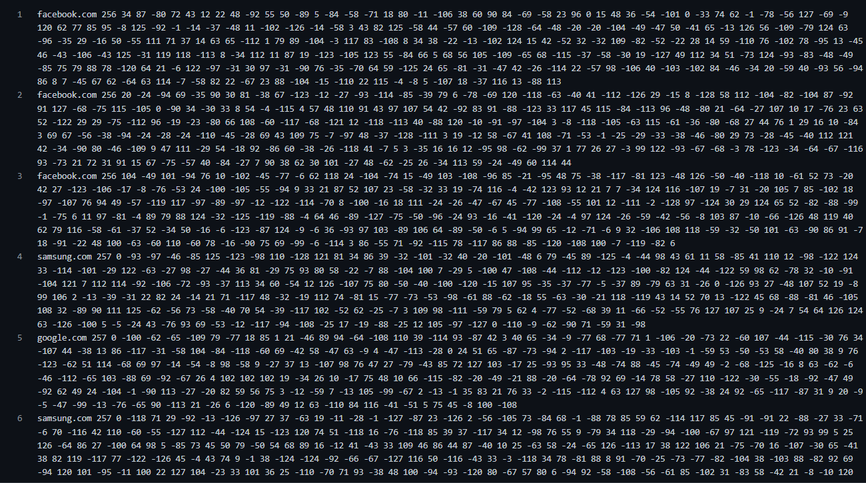

**TO STUDY AND WORK WITH KF SENSOR INTRUSION DETECTION TOOL. SETUP A HONEYPOT AND MONITOR THE HONEYPOT ON THE NETWORK.**

Honey Pot is a device placed on Computer Network specifically designed to capture malicious network traffic. KF Sensor is the tool to setup as honeypot when KF Sensor is running it places a siren icon in the windows system tray in the bottom right of the screen. If there are no alerts then green icon is displayed.

**HONEY POT:**

A honeypot is a computer system that is set up to act as a decoy to lure cyber attackers, and to detect, deflect or study attempts to gain unauthorized access to information systems. Generally, it consists of a computer, applications, and data that simulate the behavior of a real system that appears to be part of a network but is actually isolated and closely monitored. All communications with a honeypot are considered hostile, as there's no reason for legitimate users to access a honeypot. Viewing and logging this activity can provide an insight into the level and types of threat a network infrastructure faces while distracting attackers away from assets of real value.

Honeypots can be classified based on their deployment (use/action) and based on their level of involvement. Based on deployment, honeypots may be classified as:

* Production honeypots
* 2. Research honeypots

**Production honeypots** are easy to use, capture only limited information, and are used primarily by companies or corporations. Production honeypots are placed inside the production network with other production servers by an organization to improve their overall state of security. Normally, production honeypots are low-interaction honeypots, which are easier to deploy. They give less information about the attacks or attackers than research honeypots.

**Research honeypots** are run to gather information about the motives and tactics of the Black hat community targeting different networks. These honeypots do not add direct value to a specific organization; instead, they are used to research the threats that organizations face and to learn how to better protect against those threats.

**KF SENSOR:**

KFSensor is a Windows based honeypot Intrusion Detection System (IDS). It acts as a honeypot to attract and detect hackers and worms by simulating vulnerable system services and trojans. By acting as a decoy server it can divert attacks from critical systems and provide a higher level of information than can be achieved by using firewalls and NIDS alone. KFSensor is a system installed in a network in order to divert and study an attacker’s behavior. This is a new technique that is very effective in detecting attacks.

The main feature of KFSensor is that every connection it receives is a suspect hence it results in very few false alerts. At the heart of KFSensor sits a powerful internet daemon service that is built to handle multiple ports and IP addresses. It is written to resist denial of service and buffer overflow attacks. Building on this flexibility KFSensor can respond to connections in a variety of ways, from simple port listening and basic services (such as echo), to complex simulations of standard system services. For the HTTP protocol KFSensor accurately simulates the way Microsoft’s web server (IIS) responds to both valid and invalid requests. As well as being able to host a website it also handles complexities such as range requests and client side cache negotiations. This makes it extremely difficult for an attacker to fingerprint, or identify KFSensor as a honeypot.

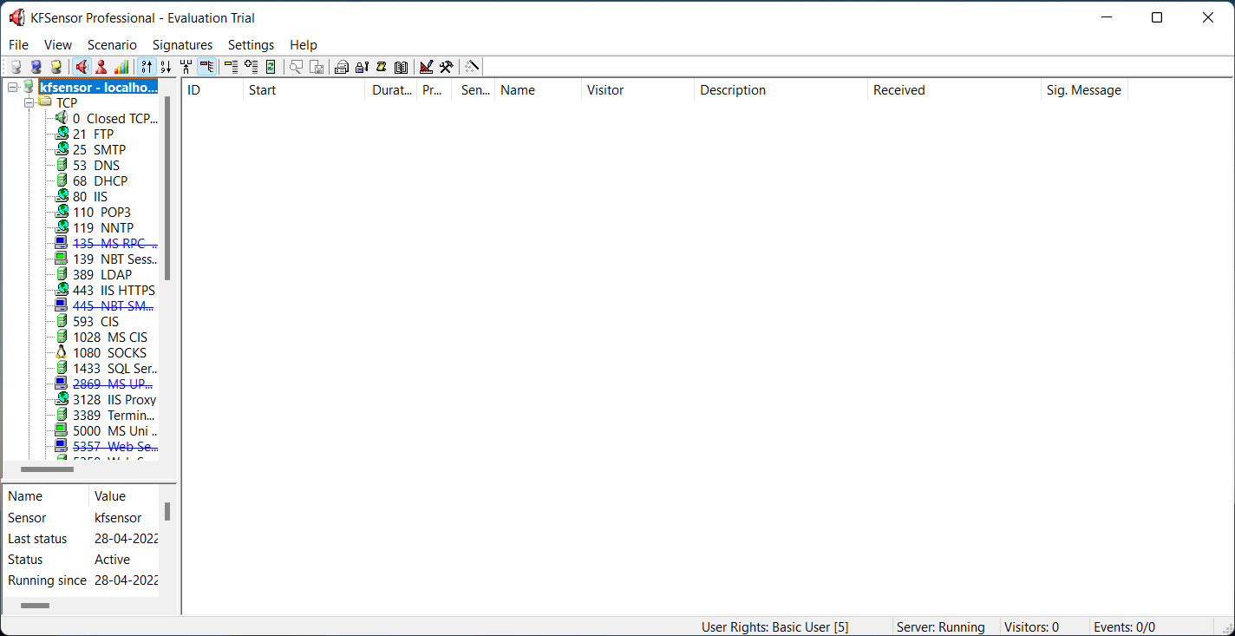

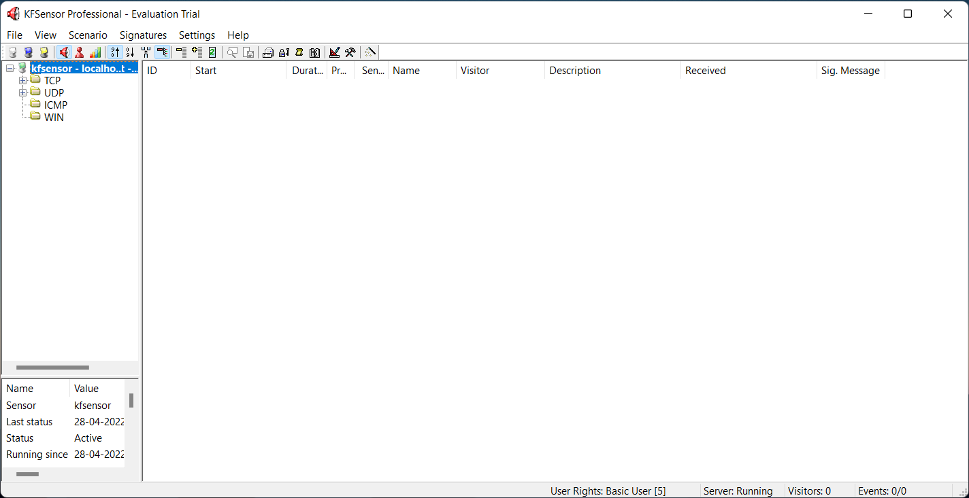

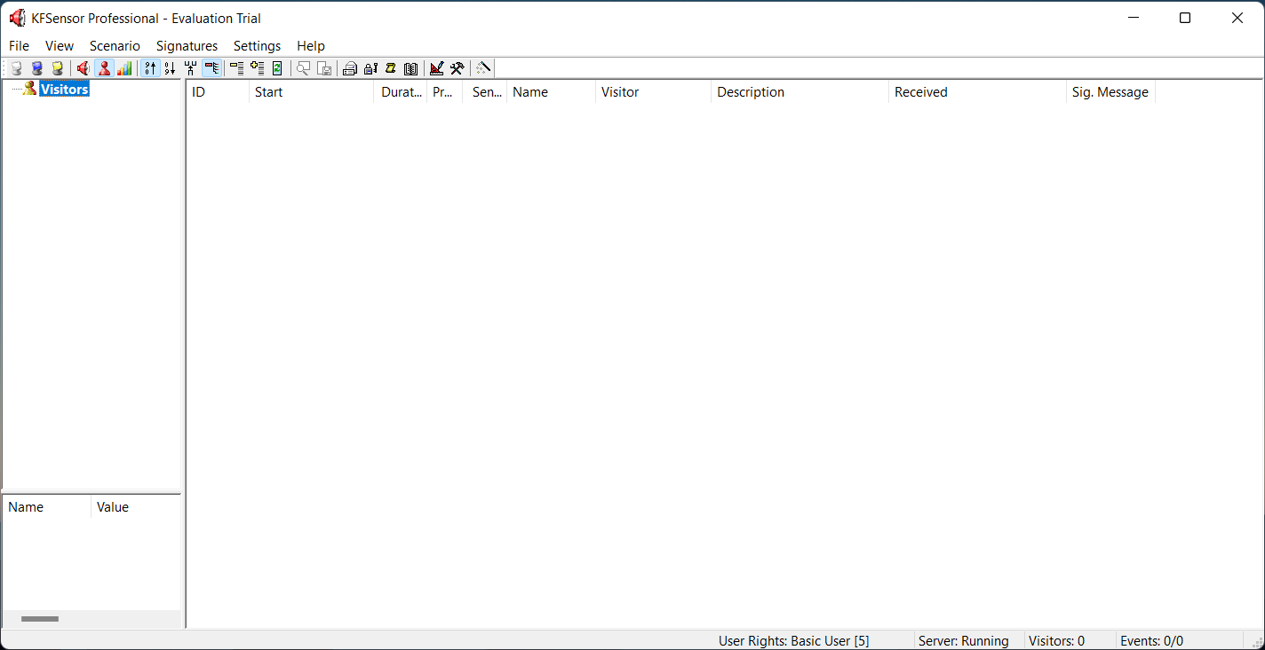

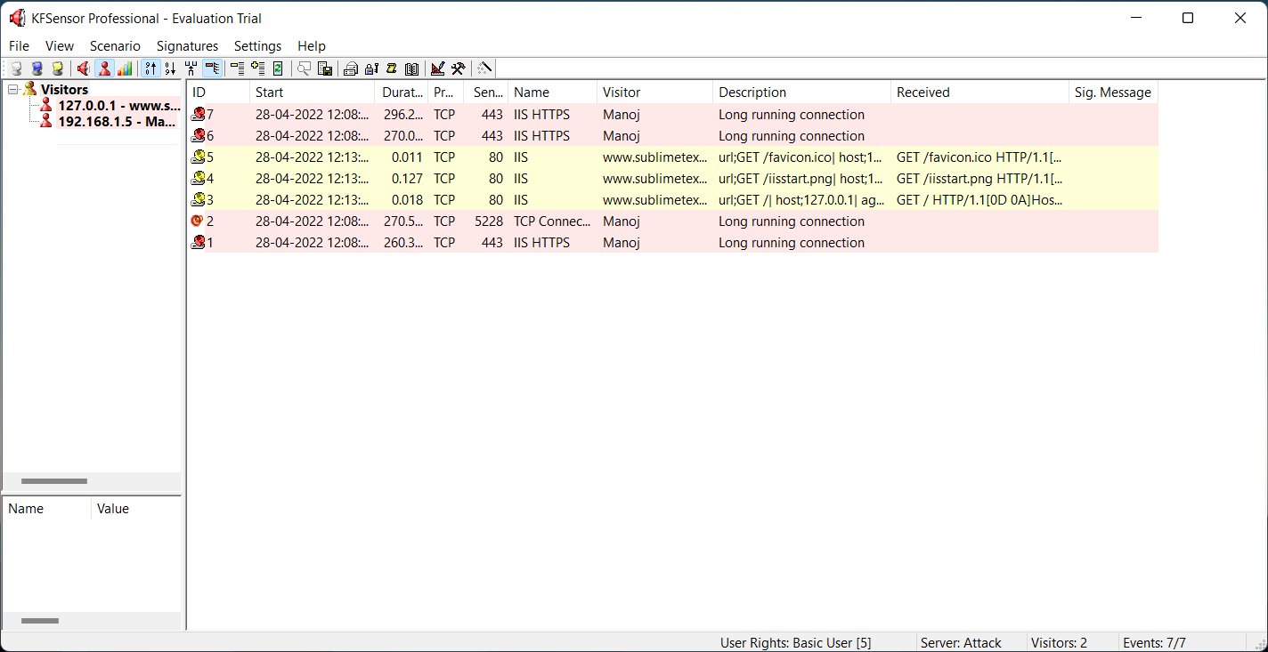

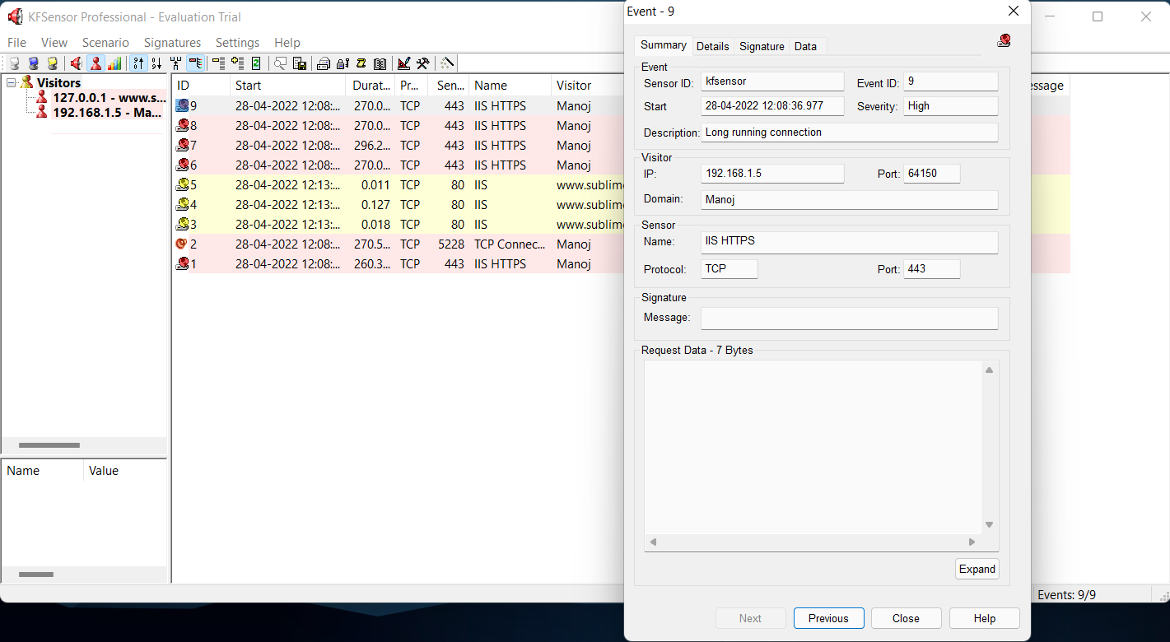

**TO WORK WITH SNORT TOOL TO DEMONSTRATE INTRUSION DETECTION SYSTEM. DOWNLOAD SNORT FROM SNORT.ORG.**

Snort is an open-source network intrusion detection system (NIDS) and it is a packet sniffer that monitors network traffic in real time.

**INTRUSION DETECTION SYSTEM**:

Intrusion detection is a set of techniques and methods that are used to detect suspicious activity both at the network and host level.

Intrusion detection systems fall into two basic categories:

* Signature-based intrusion detection systems
* Anomaly detection systems.

Intruders have signatures, like computer viruses, that can be detected using software. You try to find data packets that contain any known intrusion-related signatures or anomalies related to Internet protocols. Based upon a set of signatures and rules, the detection system is able to find and log suspicious activity and generate alerts.

Anomaly-based intrusion detection usually depends on packet anomalies present in protocol header parts. In some cases these methods produce better results compared to signature-based IDS. Usually an intrusion detection system captures data from the network and applies its rules to that data or detects anomalies in it. Snort is primarily a rule-based IDS, however input plug-ins are present to detect anomalies in protocol headers.

**SNORT TOOL:** Snort is based on libpcap (for library packet capture), a tool that is widely used in TCP/IPtraffic sniffers and analyzers. Through protocolanalysis and content searching and matching, Snort detects attack methods, including denial of service, buffer overflow, CGI attacks, stealthport scans, and SMB probes. When suspicious behavior is detected, Snort sends a real-time alert to syslog, a separate 'alerts' file, or to apop-up window. Snort is currently the most popular free network intrusion detection software.

The advantages of Snort are numerous. According to the snort web site, “It can perform protocol analysis, content searching/matching, and can be used to detect a variety of attacks and probes, such as buffer overflow, stealth port scans, CGI attacks, SMB probes, OS fingerprinting attempts, and much more” (Caswell).

One of the advantages of Snort is its ease of configuration. Rules are very flexible, easily written, and easily inserted into the rule base. If a new exploit or attack is found a rule for the attack can be added to the rule base in a matter of seconds. Another advantage of snort is that it allows for raw packet data analysis.

**SNORT can be configured to run in three modes:**

1. Sniffer mode

2. Packet Logger mode

3. Network Intrusion Detection System mode

**1. Sniffer mode**

* Snort –v Print out the TCP/IP packets header on the screen
* Snort –vd show the TCP/IP ICMP header with application data in transmit

**2. Packet Logger mode**

* snort –dev –l c:\log [create this directory in the C drive] and snort will

automatically know to go into packet logger mode, it collects every packet it

sees and places it in log directory.

* snort –dev –l c:\log –h ipaddress/24:This rule tells snort that you want to

print out the data link and TCP/IP headers as well as application data into the

log directory. snort –l c:\log –b This is binary mode logs everything into a

single file.

**3. Network Intrusion Detection System mode**

* snort –d c:\log –h ipaddress/24 –c snort.conf This is a configuration file

applies rule to each packet to decide it an action based upon the rule type in

the file.

* Snort –d –h ipaddress/24 –l c:\log –c snort.conf This will cnfigure snort to

run in its most basic NIDS form, logging packets that trigger rules specifies in

the snort.conf.

**PROCEDURE:**

STEP-1: Sniffer mode snort –v Print out the TCP/IP packets header on the screen.

STEP-2: Snort –vd Show the TCP/IP ICMP header with application data in transit.

STEP-3: Packet Logger mode snort –dev –l c:\log [create this directory in the C drive] and snort will automatically know to go into packet logger mode, it collects every packet it sees and places it in log directory.

STEP-4: snort –dev –l c:\log –h ipaddress/24 This rule tells snort that you want to print out the data link and TCP/IP headers as well as application data into the log

directory.

STEP-5: snort –l c:\log –b this binary mode logs everything into a single file.

STEP-6: Network Intrusion Detection System mode snort –d c:\log –h ipaddress/24 –c snort.conf This is a configuration file that applies rule to each packet to decide it an action based upon the rule type in the file.

STEP-7: snort –d –h ip address/24 –l c:\log –c snort.conf This will configure snort to run in its most basic NIDS form, logging packets that trigger rules specifies in the

snort.conf.

STEP-8: Download SNORT from snort.org. Install snort with or without database support.

STEP-9: Select all the components and Click Next. Install and Close.

STEP-10: Skip the WinPcap driver installation.

STEP-11: Add the path variable in windows environment variable by selecting new

classpath.

STEP-12: Create a path variable and point it at snort.exe variable name path and variable value c:\snort\bin.

STEP-13: Click OK button and then close all dialog boxes. Open command prompt and type the following commands

OUTPUT

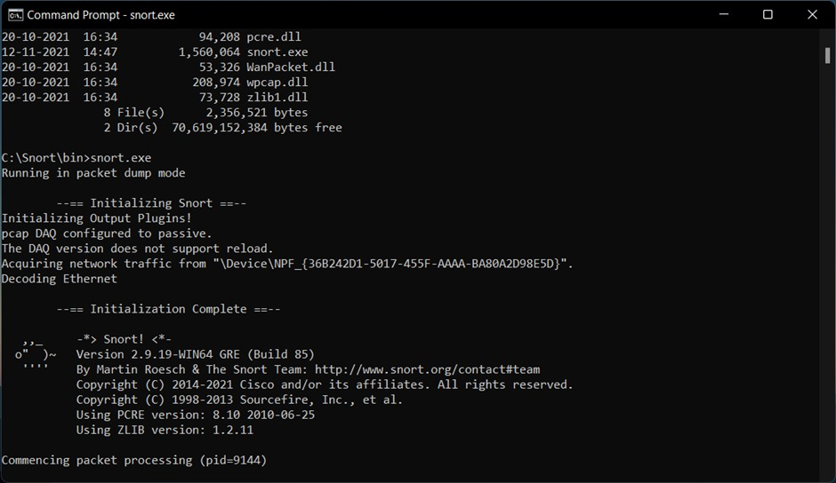

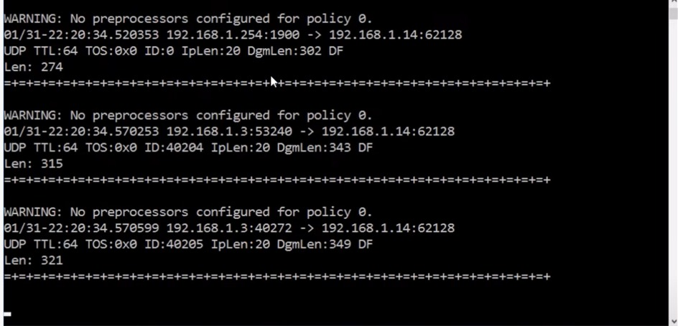

**IMPLEMENT A CODE TO SIMULATE BUFFER OVERFLOW ATTACK.**

#include<bits/stdc++.h>

int main(void)

{

    char buff[15];

    int pass = 0;

    printf("\n Enter the password :");

    gets(buff);

    if(strcmp(buff, "mypassword"))

    {

        printf ("Wrong Password \n");

    }

    else

    {

        printf ("Correct Password \n");

        pass = 1;

    }

    if(pass)

    {

        printf ("You are logged in as an administrator\n");

    }

    return 0;

}

**OUTPUT**

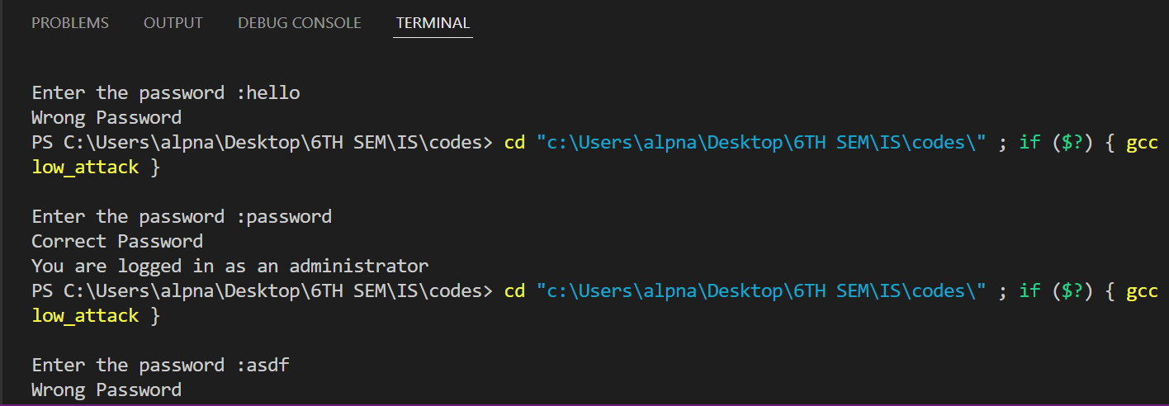

**USE THE NESSUS TOOL TO SCAN THE NETWORK FOR VULNERABILITIES**

